MEDIA RELEASE

Elatec presents logistics-oriented 4-Port UHF Reader
The long-range 868 MHz reader can connect to up to four antennae without additional hardware
Munich, October 19, 2006 — The new UHF-SR112 was developed specifically for high-performance logistics applications and offers connectors for four antennae, a reading range of up to four metres, and high processing speed. The reader is available as a standalone device, as part of a starter kit, or as an OEM board.
The compact-sized UHF-SR112 (200×150×28mm) has four RFID antenna sockets and covers a maximum reading range of roughly four metres, depending on the type of tag and the prevailing service conditions. It collects input from large amounts of low-cost transponders and is suitable for tasks that involve monitoring large data volumes. In logistics, for instance, it can be used to build RFID gates, e.g. for item tracking purposes.
To facilitate the development and testing of RFID applications, Elatec offers a starter kit with UHF-SR112, an antenna, transponders, demo software and comprehensive documentation. Experts at Elatec will gladly provide assistance if users need help developing and customizing their solutions. OEM customers may purchase just the control board (UHF-SM112) if they wish.
The standalone UHF-SR112 reader as well as the starter kit and the UHF-SM112 module are available as of now.
Further information is available at www.ElatecWorld.com or on request.

Available graphical material
The following printable graphical material is available for downloading at: http://www.htcm.de/kk/elatec
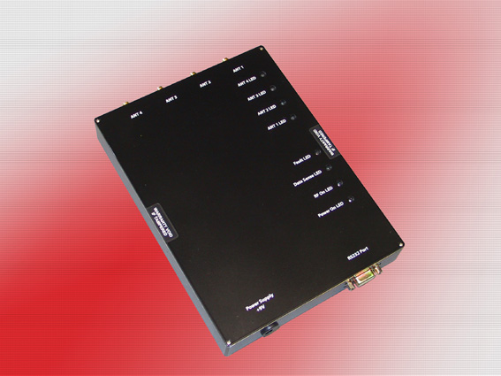 | 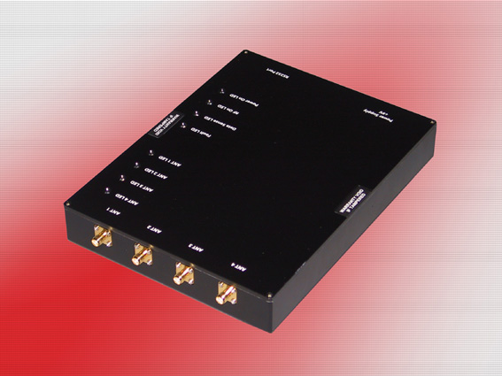

Elatec's 4-port UHF reader is particularly suitable for item tracking purposes.

Elatec—ELECTRONICS IS OUR WORLD
Elatec Vertriebs GmbH was founded in 1988 and has approx. 50 employees. The company is divided into four business units: RFID, Electronic Components, Telecom & Banking, and Engineering. The RFID division develops and distributes components and customer-specific system solutions for all application areas and all frequency ranges from 125 KHz to 5.8 GHz. The Telecom & Banking unit offers cards for telecommunications (GSM and prepaid), banking (credit, debit, and EMV chip cards), and other card-based solutions. The employees in the Engineering department support in-house development activities and collaborate on third-party projects. The Electronic Components division focuses on the company's core business, the distribution of electronic components.
Elatec has branch offices in 6 European countries and serves various other countries through a network of distributors.
Elatec Vertriebs GmbH, Hans-Stießberger-Strasse 2a, D-85540 Haar
Tel.: +49 (0)89 462307-0, Fax: +49 (0)89 462307-99
E-Mail: info@elatec.de, Homepage: www.ElatecWorld.com

Press Contact:
HighTech communications GmbH
Heike Castner
Grasserstraße 1c
D-80339 München
Tel.: +49 (0) 89 / 50 07 78-20
Fax: +49 (0) 89 / 50 07 78-78
E-Mail: h.castner@htcm.de
Homepage: www.htcm.de

