PRESS RELEASE
Important for global customers and integrators:

Elatec RFID readers receive SRRC approval for China
Munich, 4 February 2010 – Elatec is one of the first Western providers to receive SRRC approval for its RFID readers in China. After approvals in Europe (CE), USA (FCC), Canada (CI), Japan (VCCI) and Australia / New Zealand (ACA), RFID specialist Elatec has now also entered the important growth market in China. With the successful conclusion of SRRC testing, users and integrators may now introduce, use and integrate Elatec RFID readers into their own solutions in China.
After the conclusion of an eight-month-long approval process, the agencies of the People’s Republic of China have granted SRRC approval to Elatec’s RFID readers. Elatec products, such as the TWN3 universal reader, may now be introduced and implemented in China. SRRC approval in the People’s Republic of China is particularly complex; in addition to device testing in Chinese laboratories and agencies, factory visits at the manufacturer’s site are also a component of the official approval process.
For companies that want to use these RFID products in China as a user or sell them as part of an integration solution, the SRRC approval is indispensable. Because Elatec had already won approval in all of the other major world market regions (CE, FCC, CI, VCCI, ACA, etc.), international users, or providers of electronic locking systems or campus solutions, can now rely on Elatec RFID readers throughout the world, allowing them to reduce the cost of using different RFID variants.

Available images
The following images are available in printable quality for download at:
http://www.htcm.de/kk/elatec
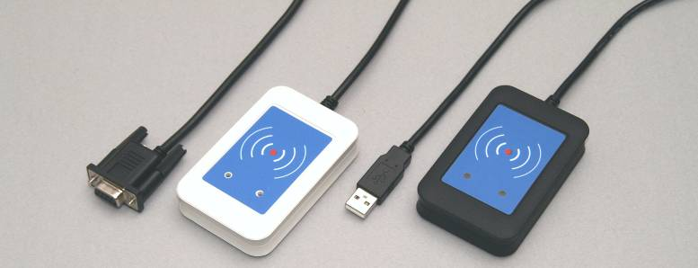
With the successful conclusion of SRRC testing, users and integrators may now introduce, use and integrate Elatec RFID readers into their own solutions in China.

Elatec Vertriebs GmbH
Elatec develops RFID reader systems and acts as a distributor with a highly specialised focus on semiconductors, industrial computer systems as well as display technologies and solutions. Elatec has nine sales and marketing offices across all of East-Central Europe and supplies all market segments of the electronics industry with a broad range of products from leading manufacturers. For more information about Elatec please visit www.ElatecWorld.com.

RFID PR contact at Elatec:
Stefan Haertel, Department Director RFID
Hans-Pinsel-Str. 10b
D-85540 Haar
Phone: +49 89 4623 07 0
Fax : +49 89 4623 07 99
E-Mail: RFID@elatecworld.com

Press contact:

HighTech communications GmbH Tel.: +49 89 500778-20
Heike Mittmann Fax: +49 89 500778-78
Grasserstraße 1c E-mail: h.mittmann@htcm.de
D-80339 München Web site: www.htcm.de

