PRESS RELEASE

30 years of Hufschmied machining systems
The right tool for every material
Bobingen (Germany), March 31, 2021 - Hufschmied Zerspanungssysteme GmbH was founded on April 1, 1991 by Rudolf M. Hufschmied and his son Ralph Hufschmied as an industrial representative for technology products in the field of machining. Over the course of its 30-year history, the company has developed into a machining tool manufacturer and ultimately a globally recognized expert in the optimization of machining processes. Today, Hufschmied develops and interacts with leading companies and research institutes working with new materials, especially composites (e.g. CFRP, GFRP) - with a focus on industries such as medical technology, automotive, aerospace, tool and die making, and machine construction. Hufschmied supplies special tools and advises customers on how to produce more efficiently and with the highest quality by matching the tool, machine and CAM strategy to materials and workpieces. The newest innovation from the company's development center is an inline quality control system for machining processes: SonicShark®.

The construction of his own tools was at first only a side project for mechanical engineer Ralph Hufschmied. This quickly changed: An automotive customer had a problem with the production of a new type of airbag cover and Ralph Hufschmied developed the solution with a special tool geometry. A few trial molds turned into a large order. In 1998, the sports car, which owed its instrument panel to this tool development, conquered the market and the design of cutting tools for new materials became Hufschmied's business model.

"A new world was opening up for us when we realized how great the demand was for machining solutions for plastics and fiber composites," remembers Ralph Hufschmied. "Composite materials were becoming increasingly important for aerospace and automotive engineering, among others - high-tech materials that, however, had to be reworked by hand due to a shortage of suitable machining solutions. We were able to offer solutions based on innovative cutting edge geometries and coatings. Tools for other problematic materials such as graphite or ceramics were then added."

Own production on the Swabian Alb
In 2003, the new company building in Bobingen near Augsburg was occupied. However, the urgent need to manufacture special tools in-house was thwarted by the fact that there were no suitably qualified skilled workers in the area around Augsburg at the time. In 2005, the medium-sized company seized the favorable opportunity, took over a tool grinding company in Winterlingen and so established its own production. In 2016, the company headquarters in Bobingen was expanded to include an engineering center for process optimization in customer projects. In 2018, a tool development center equipped with the latest generation of high-precision 3-D measuring equipment was added to further strengthen research into quality factors in machining. Here, for example, the SonicShark® inline quality control system based on the analysis of machining noise was developed.

New materials need new strategies
In an ongoing dialog with universities, mechanical engineers and applicators, Hufschmied is constantly driving forward the development of process-optimizing tools. Hufschmied is a member of numerous networks of top companies and research institutions, including Composites United e.V. and MAI Carbon, where Ralph Hufschmied is on the board and also represents SME interests, among other things.
Hufschmied Zerspanungssysteme GmbH supports several university projects and also focuses on promoting young talent in its own company: 10 percent of the employees, currently numbering around 130, are trainees - Hufschmied has had 53 trainees since the company was founded. Hufschmied maintains subsidiaries and sales and distribution partnerships worldwide.

Available images
The following images can be downloaded from the Internet in printable quality:
http://www.htcm.de/kk/hufschmied

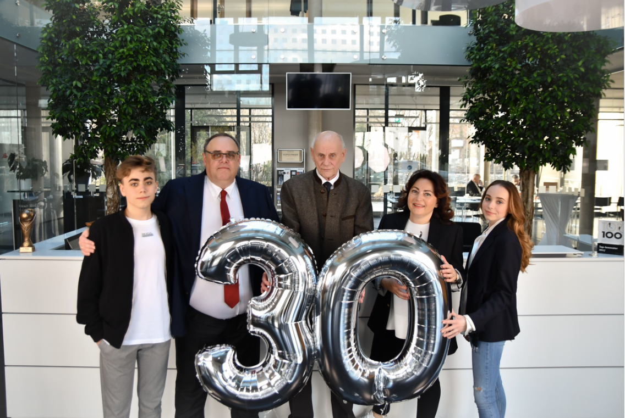Source: Hufschmied Zerspanungssysteme
The Hufschmied family is proud of 30 years of Hufschmied Zerspanungssysteme. In the picture Ralph Hufschmied (2nd from left), technical management; with Rudolf M. Hufschmied, father and company co-founder (middle); Christel Hufschmied, wife of Ralph Hufschmied and commercial management (2nd from right) with son Matthias Hufschmied and daughter Victoria Hufschmied.

  Source: Hufschmied Zerspanungssysteme  Rudolf M. Hufschmied (l.) and his son Ralph Hufschmied founded Hufschmied Zerspanungssysteme GmbH in April 1991. | 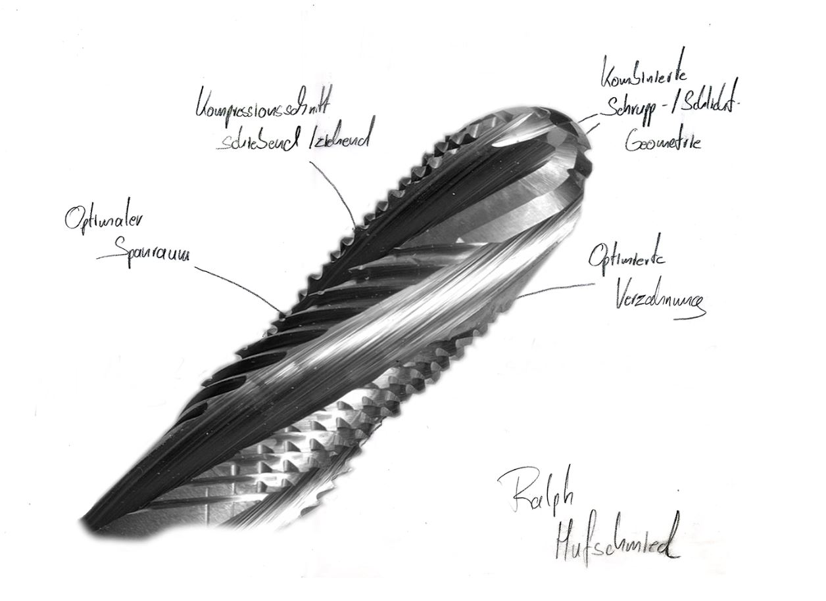  Source: Hufschmied Zerspanungssysteme  Drawing made by Ralph Hufschmied in 2016 on the Graftor®, a new milling tool with nanocrystalline diamond coating (DIP®), specialized for graphite machining.

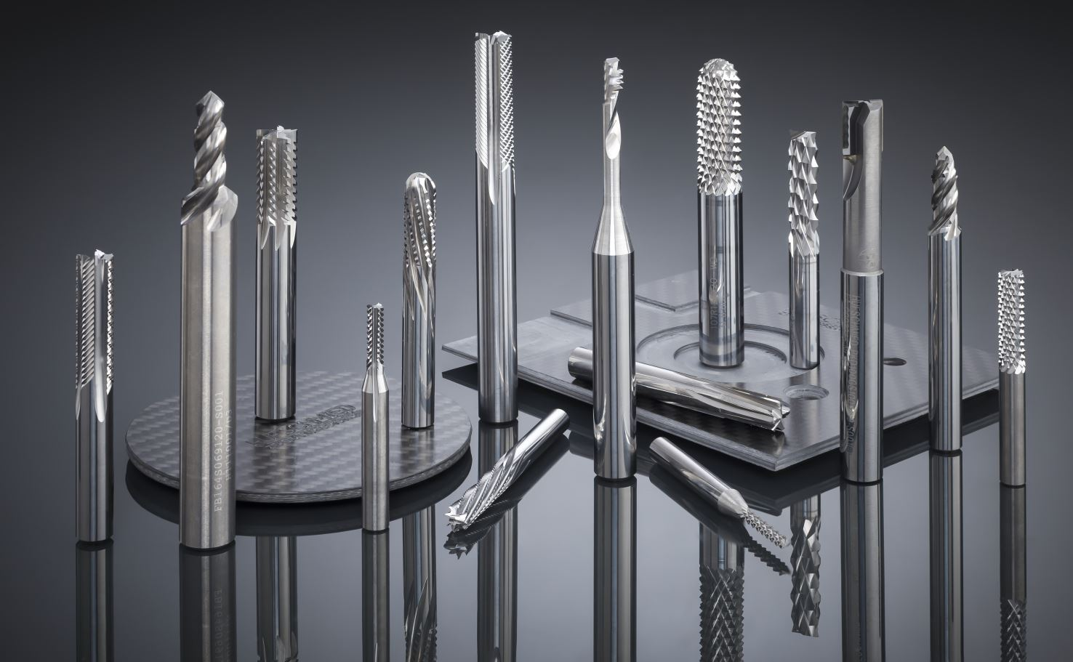Source: Hufschmied Zerspanungssysteme  Hufschmied offers the optimum tools for all materials. The picture shows tools specially made for machining carbon fiber reinforced plastic (CFRP). | 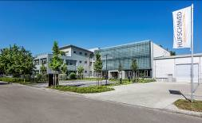Source: Hufschmied Zerspanungssysteme  The view of the current headquarters: an engineering center was added in 2016 and a tool development center in 2018.

About Hufschmied Zerspanungssysteme GmbH
Established in 1991 and headquartered in Bobingen near Augsburg, Hufschmied Zerspanungssysteme GmbH is a manufacturer of high-quality tools for machinable production. By specializing at an early stage in the machining of plastics, fiberglass materials and carbon fiber, Hufschmied has become a leader in Europe in the development of solutions for new materials. The company is an established system supplier to renowned machine tool manufacturers. Tools and manufacturing process consulting from Hufschmied are particularly valued in the automotive and aerospace industries as well as in medical technology. The company is involved in numerous organizations, including Composites United Deutschland e. V. Hufschmied's manufacturing operations are located in Winterlingen in the Swabian Alb. Hufschmied is the only tool manufacturer with its own diamond coating plant.

For more information: www.hufschmied.net
Additional information:  Hufschmied Zerspanungssysteme GmbH  Sybille Schuller  Edisonstrasse 11d  86399 Bobingen  Germany  Phone: +49 8234 9664-0  Telefax: +49 8234 9664-99  E-Mail: info@hufschmied.net  www.hufschmied.net | Press contact:  HighTech communications GmbH  Brigitte Basilio  Brunhamstrasse 21  81249 Munich  Germany  Phone: +49 89 500778-20  Telefax: +49 89 500778-77  E-Mail: b.basilio@htcm.de  www.htcm.de

