Press Release
Videonize: A video e-mail system is well-received in the deaf community
2007 World Deaf Tennis Cup 2007: International attention for e-mail-communication in sign language
Reno/Munich, 29. August 2007 – “Videonize”, the next generation of e-mail communication, has found a great reception in the deaf community. This form of video e-mail allows deaf people to communicate using sign language through their e-mail system. During the 2007 World Deaf Tennis Cup (July 21-28 in Munich) the new system was demonstrated live for the first time in public to the international deaf community. Dr. Donalda Ammons, President of the International Committee of Sports for the Deaf (ICSD), hailed Videonize as a new way for many different deaf groups to organize and coordinate through video e-mail. MailPerfect has now arranged a portal directly for those using sign language under http://deaf.videonize.de/english/ with a lot of information to help getting started in the video e-mail world. In the course of September, the third channels of the ARD German Television will show a detailed report on deaf communication by Videonize in the telecast "Sehen statt Hören" (what means "seeing instead of hearing").
Markus Meincke, MailPerfect’s Manager for the European Deaf Community Projects, made a well received presentation of the advantages of Videonize for deaf people to visitors from over 20 countries at the 2007 World Deaf Tennis Cup. Finally, deaf people can speak over the Internet e-mail system using the sign language to which they are used and send it to their friends and family. Using it is very easy. A Videonize mail is very small, only a few KB. Once connected, a streaming video opens and streams without delay. It also takes no space on the hard disk.

Videonize strengthens the international gesture communication
Meincke talked about how simple it is to use the new videomail system using International Sign Language (ISL). This is much easier for deaf people of many countries to understand than foreign languages in different texts. The users of Videonize mail benefit in a number of ways. They can now understand the message in their own sign language, and the response is also just as easy —direct through the e-mail program or a web browser.
There’s a Videonize website especially for the deaf: http://deaf.videonize.de, where the advantages of Videonize for sign language are explained. Support for all questions related to the installation and use of the Videonize technology is provided via video-telephony, instant messanger, e-mail and, of course, via Videonize mails by specialists trained in German and international sign language. Interested users also find here immediately the direct connection at the spare time and community network deaf-vilago21 for behaving Videonize users by using the "DEAF COMMUNITY" button.

Radiation in "Sehen statt Hören" in the third channels of the ARD
The president of the International Committee of Sports for the Deaf (ICSD), Dr. Donalda Ammons, is convinced of the many advantages for the deaf community. “The 96 national sports federations of the ICSD can benefit in many ways from Videonize,” she said. She is pleased at the support shown by top management at MailPerfect for their commitment to the deaf community.
From the developing of a video message to the receipt of video by e-mail up to the customer support specific for target groups in sign language: The TV broadcasting ”Committee", the weekly magazine for hearing injured person, lights up the new communication form for sign language on the Internet in September. The shot for the production of the Bavarian television (BR) took place within the scope of the World Deaf Tennis Cup in the European headquarters of MailPerfect in Unterhaching near Munich. The contribution likewise shows the detailed interview with ICSD president Dr. Ammons. The single radiation appointments in the third channels of the ARD are performed on the broadcasting web page under:
www.br-online.de/br-intern/sendungen/sehenstatthoeren

For further information, go to www.mailperfect.eu.

Available graphical material
The following graphical material is printable available at:
http://www.htcm.de/kk/mailperfect
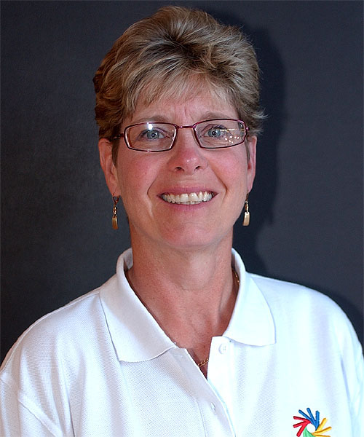  Dr. Donalda Ammons, President of the International Committee of Sports fort he Deaf (ICSD), is impressed from the possibilities Videonize offers for the communication in sign language | 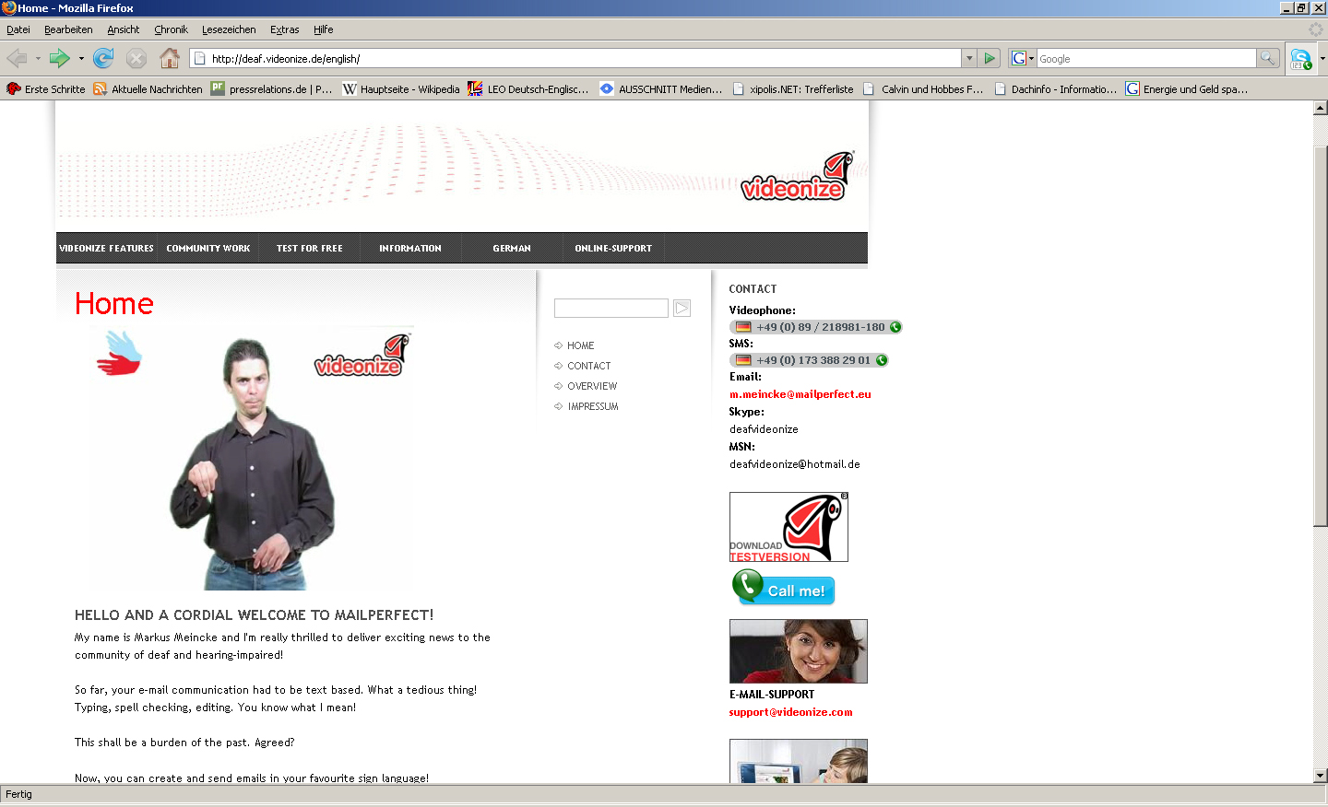  deaf.videonize.de: Videonize explained in sign language

About MailPerfect Europe AG
Munich-based MailPerfect Europe AG is the European business unit operating as a subsidiary of MailPerfect Corporation USA. The parent company for the MailPerfect Group is MailPerfect Holding PLC, UK, traded on the Frankfurt stock exchange under the ticker symbol MPP1.
MailPerfect develops and distributes Videonize technology, integrating video messages simply and directly into all current email programs. Videonize email will supplant text-dominant messages and will establish itself as the next generation in personal and commercial email communication.
By providing standard software, IT infrastructure, and support service, MailPerfect enables the application of Videonize technology to all areas of email communication: private users, organizational communication (internal, B2B, B2C), marketing and advertising.
MailPerfect Europe AG, Inselkammerstraße 1, D-82008 Unterhaching
Tel.: + 49 (0) 89 / 218981-0, fax: + 49 (0) 89 / 218981-100
E-mail: Info@mailperfect.eu, homepage: www.mailperfect.eu

Press contact:
HighTech communications GmbH
Barbara Ostermeier
Grasserstraße 1c
D-80339 Munich
Tel.: + 49 (0) 89 / 50 07 78-10
Fax: + 49 (0) 89 / 50 07 78-78
E-mail: b.ostermeier@htcm.de
Homepage: www.htcm.de

Interview contact
MailPerfect Europe AG
Uwe Schmidt, chairperson of the board of directors
Inselkammerstraße 1
82008 Munich-Unterhachings
Tel.: + 49 (0) 89 / 21 89 81-0
Fax: + 49 (0) 89 / 21 89 81-100
E-mail: presse@mailperfect.eu
Homepage: www.mailperfect.eu

