MEDIA INFORMATION
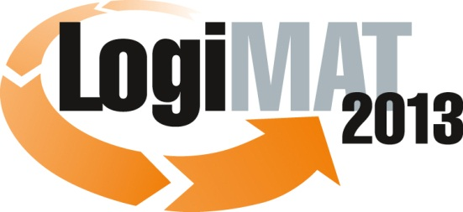
Hall 4, stand no. 634
S+P Samson at LogiMAT 2013
Highlights: Full identification using barcode or RFID
Kissing, 6 November 2012 – At LogiMAT 2013 (19 - 21 February 2013, Neue
Messe Stuttgart) S+P Samson GmbH of Kissing, Germany, will be focussing on the subject of intralogistics.
The industrial identification specialists will be presenting solutions for the identification of individual items or containers that ensure automatic status tracking. Robust Kanban cards and workflow documents made of GRAPHIPLAST® for laser printers enable full traceability via barcode technology and RFID. This ensures that items are booked in and out of stock in real time and prevents material planning errors. Efficiency in internal logistics creates transparency and helps to control stock management costs.
Another highlight on the S+P stand will be the flexible, multi-functional GRAPHIPLAST® labels - with a partial adhesive field - which can be used either as a tag or as a self-adhesive label, providing a secure data carrier. This is a robust document for a wide range of applications (incoming goods, shipping, etc.) The labels and tags are made from plastic and are virtually indestructible, yet can be printed like paper. The labels and tags replace protective wallets, therefore reducing costs.
S+P data carriers are ideal for industrial identification using laser or thermal transfer printers. For very exposed applications, S+P can provide protective covers which protect the printer against dust and moisture. RFID units for laser and thermal transfer printers ensure safe data transmission and verification of the printed data carrier.
Leading companies in mechanical engineering, automotive and chemical industries use S+P GRAPHIPLAST® as workflow documents or labels and tags in production, shipping and warehouse logistics.
On its stand no. 634 in hall 4, S+P Samson will be showing examples from actual applications from around the world of “industrial identification“.
Further details are available at www.sp-samson.com or on request.

Available images
The following printable images are available for downloading from:
http://www.htcm.de/kk/spsamson/
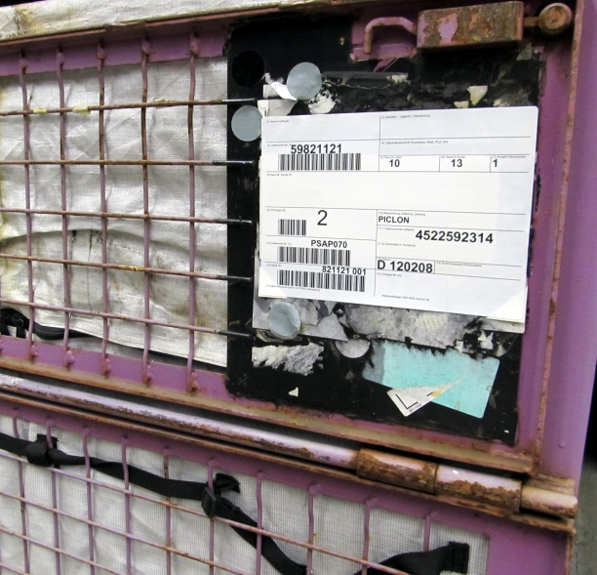
Image source: S+P Samson
Self-adhesive S+P GRAPHIPLAST® label on a container.

S+P Samson GmbH
Since 1978 the S+P Samson GmbH has been manufacturing robust plastic labels and tags under the motto “Strong solutions for rough environmental conditions“. GRAPHIPLAST® labels and tags, renowned worldwide, are weather-resistant data carriers for temperatures up to 850 °C which can be printed with conventional IT printing systems. This enables secure identification when booking goods into and out of stock as well as during the various processing steps.
To complete the portfolio, S+P work with a number of trusted partners: in addition to data carriers, automatic labelling solutions, printing systems, barcode reading systems and RFID-based systems also form part of the comprehensive range of identification solutions.
Leading companies worldwide in the steel, chemical and automotive industries work with S+ P and a comprehensive network of sales offices and agents ensures a speedy local service for customers.
S+P Samson GmbH employs around 70 people and, in 2011, the turnover was Euro 17.5 million.

Contact:
S+P Samson GmbH
Mr. Stefan Heinzler
Marketing and Sales Director
Postfach 1140
86425 Kissing
Germany
Telephone: +49 8233 846-0 Fax: +49 8233 846-299
E-Mail: info@sp-samson.com

