Press Release

Markt Indersdorf (Germany), 9 April 2014

Organisational Changes in the Management at Sumitomo (SHI) Cyclo Drive Germany GmbH:
Sumitomo (SHI) Cyclo is reorganising its top management
Sumitomo (SHI) Cyclo Drive Germany GmbH, which has its headquarters in Markt Indersdorf near Munich, has reorganised its management and has restructured part of the company. In June 2013, Managing Director, CEO and PTC EMEA President Shaun Dean, a proven production specialist with international management experience, took over the management of the European headquarters of the gearbox specialist and took the time to analyse the company's strategies, structures and processes in detail. On the first of February this year he presented the new management to the staff and the works council.
Dr. Johann Hopfner, long-term leader of Engineering and Development at Sumitomo (SHI) Cyclo, will be taking over Engineering and Development, Quality Management and IT departments as General Manager (Chief Technical Officer).
Takeshi Okabe will be responsible for the Purchasing and Production departments as General Manager (Chief Operating Officer). Mr. Okabe held various positions at the Japanese parent company Sumitomo Heavy Industries, Ltd. (SHI), focusing on production, worked in Markt Indersdorf from 1995 to 2002, and introduced the global production system, among other things.
Shaun Dean, European CEO of SHI for the Drive Technologies Division and board member of the affiliated company Hansen Industrial Gearboxes in Belgium, is satisfied that he has been able to acquire two experienced leaders for the management team in Mr. Okabe and Dr. Hopfner. The various different nationalities in the leadership team also emphasise the future strategy.
Mr. Dean declared that "we need to cooperate more closely again with the international companies that belong to our group, to use synergies and to optimise our product policy - above all in order to meet the technical and economic challenges of our customers in Europe and to strengthen our market presence".
Global strategies are currently also being fine-tuned at the Japanese parent company and the next round of product innovations is being developed. The European market is an important strategic goal in this process, and our customers in the machine tools, robotics, automation and materials handling industries and providing us with plenty of important feed that we must implement.

Available photos and images
The following photos and images are available on the internet for downloading and printing:
http://www.htcm.de/kk/sumitomo

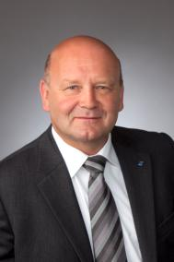  Photo/image source: Sumitomo (SHI) Cyclo Drive Germany GmbH  Shaun Dean, Managing Director, CEO at Sumitomo (SHI) Cyclo Drive Germany |   Photo/image source: Sumitomo (SHI) Cyclo Drive Germany GmbH  Dr. Johann Hopfner, Managing Director, CTO at Sumitomo (SHI) Cyclo Drive Germany | 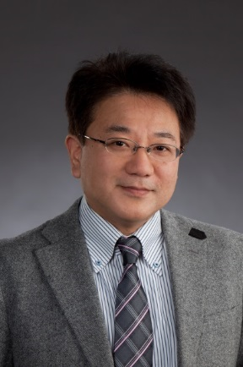  Photo/image source: Sumitomo (SHI) Cyclo Drive Germany GmbH  Takeshi Okabe, Managing Director, COO at Sumitomo (SHI) Cyclo Drive Germany
About SUMITOMO (SHI) CYCLO DRIVE GERMANY GmbH:
SUMITOMO (SHI) CYCLO DRIVE GERMANY GmbH is a subsidiary of Sumitomo Heavy Industries in the Power Transmission Control business segment. In 2012, Sumitomo Heavy Industries generated an annual turnover of 5.9 billion US dollars. Under the umbrella brand of SUMITOMO DRIVE TECHNOLOGIES, Sumitomo Heavy Industries is the market leader for drive technology in Japan and continues to expand its global presence and market share. Thus, SUMITOMO (SHI) CYCLO DRIVE GERMANY GmbH has sales, service and production facilities in many European countries and subsidiaries in France, Italy, Spain, Sweden, Great Britain and Turkey.
SUMITOMO (SHI) CYCLO DRIVE GERMANY GmbH is exhibiting at the following trade fairs in 2014:
WIN Automation, Istanbul, Turkey, 19-22 March 2014
ELMIA Automation, Jönköping, Sweden, 6-9 May 2014
AUTOMATICA, Munich, Germany 3-6 June 2014
SPS/IPC/DRIVES, Nuremberg, 25-27 November 2014

Further information at: www.sumitomodrive.com
Further information:
SUMITOMO (SHI) CYCLO DRIVE GERMANY GmbH
Christiane Loichinger
Cyclostrasse 92
85229 Markt Indersdorf
Germany
Tel.: +49 8136 66-168
Fax: +49 8136 663-168
Email: cloichinger@sce-cyclo.com
Website: www.sumitomodrive.com

