PRESS RELEASE

Swissbit-SD-Cards for Bodycams – PS-100u DP, PS-45u DP and PS-45 DP
Flash Media for Evidence-Protection
Bronschhofen, Switzerland. March 20, 2017 – Swissbit, a leading manufacturer of flash memory solutions, has expanded its range of SD and microSD cards for counterfeit-proof and access-protected data storage in Bodycams. Encryption functionality labelled with the product code "DP" for "Data Protection" enables a sensible and legally viable use of cameras that are attached to the uniforms of personnel: a permanent video recording from the perspective of officials or security officers, which can only be accesses by authorized personnel and can serve as evidence in courts of law. Both the behavior of those being filmed as well as that of the Bodycam carrier is documented. Actual circumstances are recorded with ease and filmed without restricting the freedom of movement. PS-45 DP and PS-45u DP, the "DP" versions of established flash cards for industrial applications, now complement Swissbit’s microSD card PS-100u DP, which is already being used in a leading device.
Integrating data-protection functionality into low-cost standard devices is a challenge. Using Swissbit's data protection cards is, in many cases, not only technically the best solution but also the most cost-efficient. The card turns a standard video camera into a secure camera. The camera itself typically does not have to be modified to achieve secure recordings because the memory card ensures that the data cannot be accessed or read without permission. For data read-out, a library is used which performs the authentication. The owner of the card has full control and can for each case cleanly and demonstrably separate recordings, read-outs as well as administration. The combination of data protection and cryptography functionality provides AES encryption and forms the basis for authorization and access control as well as clean deletion of all data after each recording cycle. The high-quality cards are available in different storage capacities: microSD cards PS-100u DP with 8, 16 or 32GB, PS-45u DP with 4, 8, 16 or 32GB and the PS-45 DP SD-card with an additional 64GB capacity.
"For both the preservation of evidence as well as where complaints have been made about the behavior of police officers and civilian security personnel, bodycams are increasingly being used to quickly and efficiently reach a conclusive clarification. There are already many application examples worldwide. Important prerequisites for the use of bodycams are that manipulation must be technically impossible and privacy rights must be protected by strictly regulating access to any data. This is where Swissbit can help. We offer manufacturers of these cameras a cost-effective, easy-to-implement, secure video storage solution," explains Hubertus Grobbel, Head of Security Products at Swissbit AG.
Further applications
The counterfeit-proof storage of data along with strictly controlled access and evaluation rights limited to authorized persons only, can also be used for many other applications: for example video surveillance of business premises subject to provable joint control of the works council and the employer or a long-term documentation of industrial processes. The new flash-memory solutions from Swissbit can certainly be applied here. Furthermore, so-called "Dashcams" or "drones" record footage in public spaces, which can be subject to high penalties if publication is uncontrolled. If particularly durable and robust SD or microSD cards are required, Swissbit offers a further alternative: PS-450 DP and PS-450u DP have the same security features but are SLC-based (single-level cell-flash technology with a lifespan of 100,000 write-erase cycles instead of 3,000 offered by MLC). Swissbit's products are available exclusively to solution providers.

Available images
The following images are available for download in printable format at: http://www.htcm.de/kk/swissbit
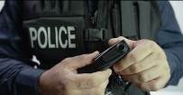  Image Source: Shutterstock.com, Skyward Kick Productions  Bodycams enable counterfeit-proof video recordings for patrols - Swissbit offers secure storage solutions. | 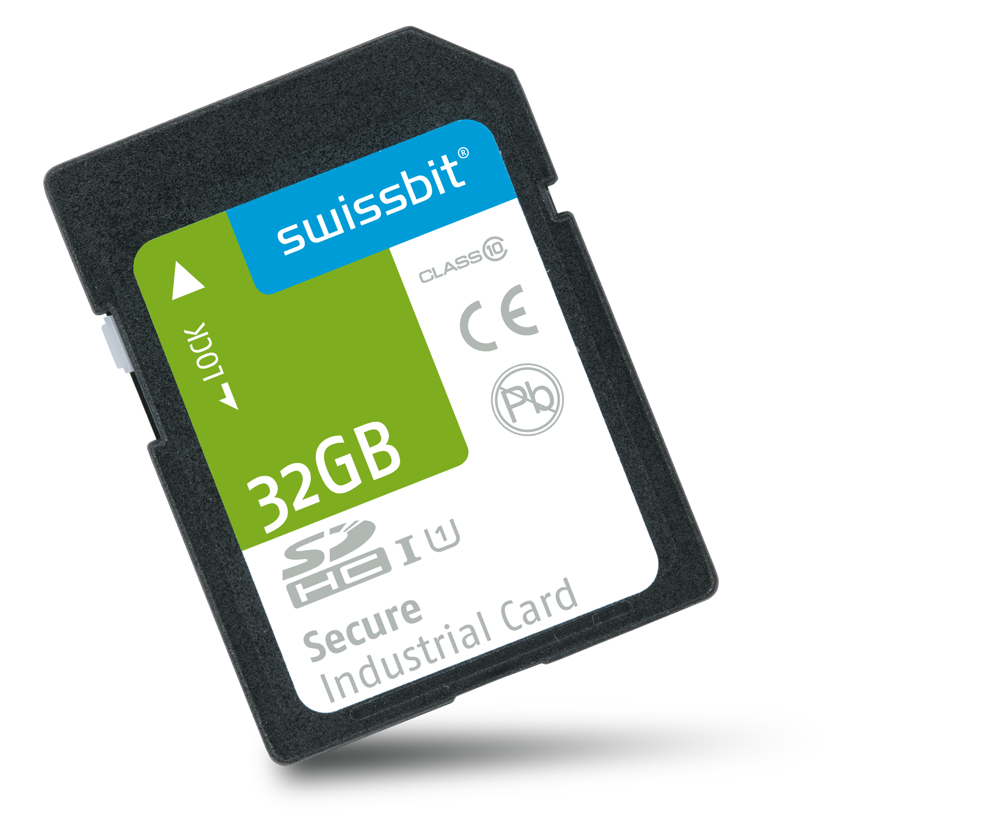  Image Source: Swissbit  Swissbit-SD-Card for Bodycams:  PS-450 with 32GB
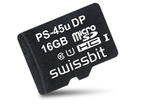  Image Source: Swissbit  microSD card PS-45u DP with 16GB | 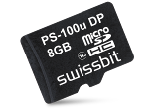  Image Source: Swissbit  microSD card PS-100u DP with 8GB

About Swissbit AG
Swissbit is the largest independent manufacturer of embedded memory and flash storage solutions in Europe. The company was founded in 2001 through a management buy-out of Siemens AG, and has offices in Switzerland, Germany, US, Japan and Taiwan. Its main manufacturing plant in Berlin produces industrial strength flash memory products and memory cards with dedicated features for demanding applications. The Swissbit flash range includes SSDs with SATA interface as mSATA, Slim SATA, CFast™, M.2 and 2.5”, CompactFlash, USB flash drives, SD and micro SD memory cards. Swissbit offers products with long-term availability, high reliability and durability and custom optimization for demanding applications in the industrial, automotive and telecommunications sectors. With its secure storage solutions, Swissbit addresses the increasing security requirements demanded by industrial, government, defense, medical, telecommunications, machine-to-machine communication and finance industry segments. All Swissbit products meet the highest quality standards and the RoHS and REACH directives.
For further information, please visit www.swissbit.com

Further Information:  Swissbit AG  Silke Lüers  Industriestrasse 4  9552 Bronschhofen  Switzerland  Tel: +41 71 913 03 39  Email: silke.lueers@swissbit.com  www.swissbit.com | Media Contact:  HighTech communications GmbH  Brigitte Basilio  Grasserstrasse 1c  80339 Munich  Germany  Phone: +49 89 500778-20  Fax: +49 89 500778-77  E-mail: b.basilio@htcm.de  www.htcm.de

