
PRESS RELEASE

Swissbit to exhibit at the EDS Summit 2017
High-End Flash Memory Solutions with Outstanding US-Customer Support
May 16-19, 2017
The Mirage, Suite C33
Bronschhofen, Switzerland. April 24, 2017 – Swissbit will showcase its high-end memory and storage products for industrial and NetCom applications at the EDS Summit in Las Vegas (The Mirage, Suite C33), taking place from May 16-19, 2017.
The leading specialist for flash memory solutions will highlight its SATA-Gen3 products with the endurance- and retention-optimized durabit™ & everbit™ ranges – such as X-60m2, X-60, X-60P. Furthermore, the company will present innovative SD memory cards with page based FTL and pSLC mode with its S-46 product range. At this key industry gathering, Swissbit will inform existing and new distributors about latest technology and application trends. The success of the flash memory specialist in the US market is not only due to its high-quality products, but also its excellent consulting expertise and outstanding support for developers and electronics companies – right through to customized memory and storage solutions.

Available images
The following images are available for download in printable format at: http://www.htcm.de/kk/swissbit
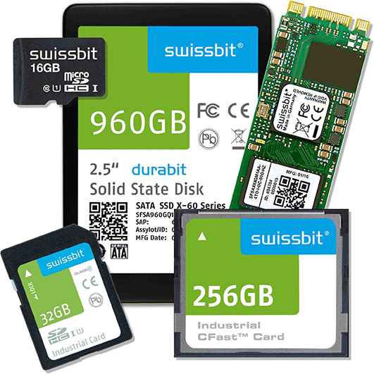
At the EDS Summit, Swissbit will showcase its SATA-Gen3 products with the endurance- and retention-optimized durabit™ & everbit™ ranges as well as SD memory cards.
Image Source: Swissbit

About Swissbit AG
Swissbit is the largest independent manufacturer of embedded memory and flash storage solutions in Europe. The company was founded in 2001 through a management buy-out of Siemens AG, and has offices in Switzerland, Germany, US, Japan and Taiwan. Its main manufacturing plant in Berlin produces industrial strength flash memory products and memory cards with dedicated features for demanding applications. The Swissbit flash range includes SSDs with SATA interface as mSATA, Slim SATA, CFast™, M.2 and 2.5”, CompactFlash, USB flash drives, SD and micro SD memory cards. Swissbit offers products with long-term availability, high reliability and durability and custom optimization for demanding applications in the industrial, automotive and NetCom sectors. With its secure storage solutions, Swissbit addresses the increasing security requirements demanded by industrial, government, defense, medical, NetCom, machine-to-machine communication and finance industry segments. All Swissbit products meet the highest quality standards and the RoHS and REACH directives.
For further information, please visit www.swissbit.com

Further Information:  Swissbit AG  Silke Lüers  Industriestrasse 4  9552 Bronschhofen  Switzerland  Tel: +41 71 913 03 39  Email: silke.lueers@swissbit.com  www.swissbit.com | Media Contact:  Scoop Communications  Kim Sauer (Mr)  Tel: +44 7906 019 022  Email: kim@wearescoop.com  Or  Philip Stoten  Tel: +1 310 591 0655  Email: phil@wearescoop.com

