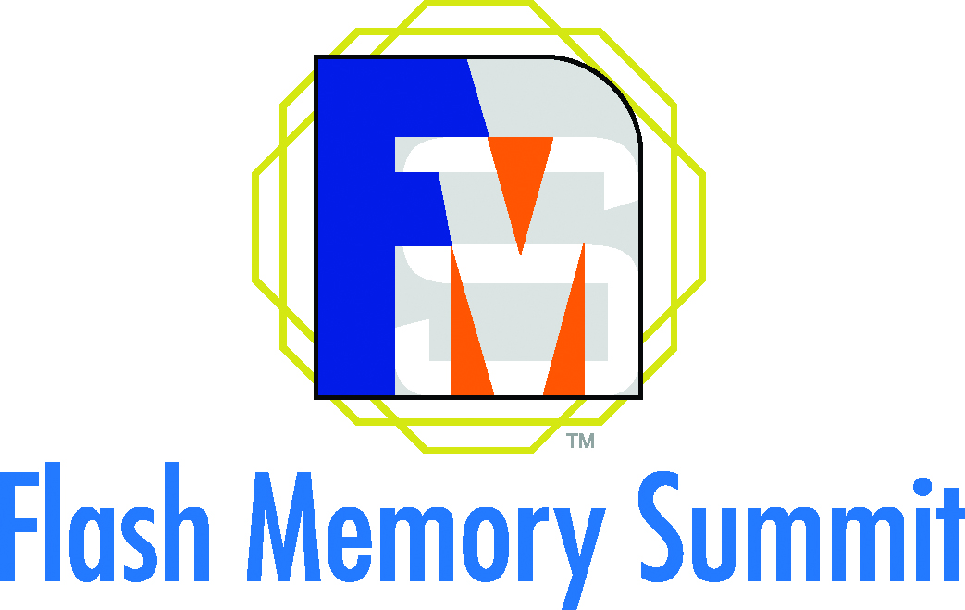
PRESS RELEASE

Meet Swissbit at the Flash Memory Summit 2017
In the Era of the IIoT: Storage Solutions for Networked Systems
August 8-10, 2017
Booth #419
Bronschhofen (Switzerland), July 20, 2017 – Swissbit, a leading manufacturer of flash memory solutions, will be exhibiting its latest memory innovations at the Flash Memory Summit 2017 in Santa Clara, California (August 8-10, 2017). On booth #419 of the Santa Clara Convention Center, Swissbit will present new additions to the SATA 6Gb/s SSD X-60 product range as well as an embedded USB 3.1 module optimized to perform as a durable boot medium. Further highlights will be the solid e.MMC EM-20 and a NVMe PCIe M.2 module prototype featuring particularly low power consumption. With its strong focus on the NetCom and IIoT markets, Swissbit will also be participating in the Summit’s conference program with a presentation entitled ‘Improving Lifetime Estimates for Embedded Flash’.
Embedded USB flash modules from Swissbit are a popular boot medium for telecommunications applications. Swissbit is now introducing the U-500 USB 3.1 module. The product not only sets itself apart by offering a durable SLC-NAND, but also by its controller, which has been specially designed for boot media requiring reliability and durability over many years. The key feature is data care management that refreshes degrading NAND pages in read-mode. Thanks to a 10Gbit/s data rate of USB 3.1 Gen 2, boot times can be significantly reduced with Swissbit’s U-500.
Exclusively for FMS-Visitors
For the first time, Swissbit will present N-10: a prototype of its innovative NVMe PCIe M.2 module. N-10 is specially tailored to the requirements of telecommunications and embedded systems. Whilst the popular 4-lane/8-channel NVMe products are tuned for the highest data rate, Swissbit’s N-10 has a different focus: With its 2-lane/4-channel architecture, N-10 can offer more than double the performance of an SSD with SATA 6Gb/s interface, and significantly reduces power consumption. The memory module can even be used in fanless systems. This would hardly be conceivable with conventional NVMe-SSDs with x4-PCIe connection. The NVMe PCIe M.2 module from Swissbit is based on 3D-NAND and features a special industrial-grade controller.
Robust and durable
Swissbit has always specialized in extremely robust and durable storage solutions for industrial and other demanding applications. Traditionally this is the domain of SLC, but Swissbit successfully makes MLC a viable option for such applications. As an example, the recently launched e.MMC EM-20, an MLC-based memory card, is also available in pSLC mode which increases endurance by a factor of 6.7.

The SATA Gen 3 SSD range from Swissbit will be a further show-highlight. The SATA 6Gb/s SSDs from the X-60 product range offer storage densities between 8 and 960GB. They are available in five different models and are characterized by their durabit™ firmware. This brand-name unites technologies for the better use of MLC chips. New additions are an M.2 SSD with 1TB based on 3D-NAND, as well as an M.2-SSD with greater protection against loss of data in case of power failure.
Selection and advice
"Our small-form factor products, the newly introduced e.MMC EM-20 and our security solutions successfully position us in the highly competitive IIoT market," says Ulrich Brandt, Director of Marketing at Swissbit. "We are looking forward to the Flash Memory Summit. We are confident that with the wide selection of SLC, MLC and pSLC products displayed on our booth along with expert advice from our colleagues and partners, customers from industries such as telecommunications, industrial and IIoT will discover that Swissbit offers the most suitable product for their application."

A key question asked by embedded systems developers will be addressed by Thomas McCormick, Chief Engineer/Technologist at Swissbit in his presentation ‘Improving Lifetime Estimates for Embedded Flash’. JEDEC defines consumer and enterprise workloads, but not for embedded systems. In his presentation, McCormick will suggest a possible workflow model, which would enable an estimation of the storage life for such applications.

Available images
The following images are available for download in printable format at: http://www.htcm.de/kk/swissbit

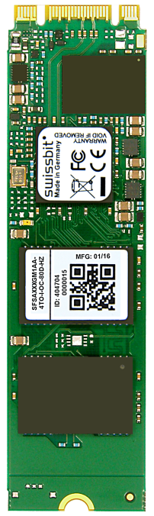  Image Source: Swissbit  At the Flash Memory Summit Swissbit will present a M.2-SSD with 1TB memory from the SATA 6Gb/s SSD-product range. | 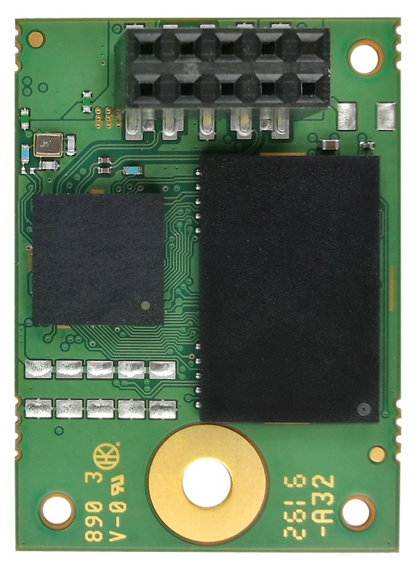  Image Source: Swissbit  Swissbit U-500: an embedded USB 3.1-module optimized as a durable boot medium.

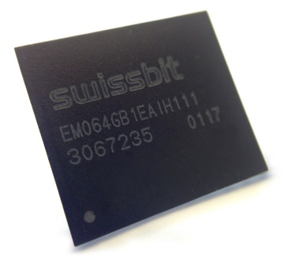  Image Source: Swissbit  New memory-solution from Swissbit: the e.MMC EM-20 | 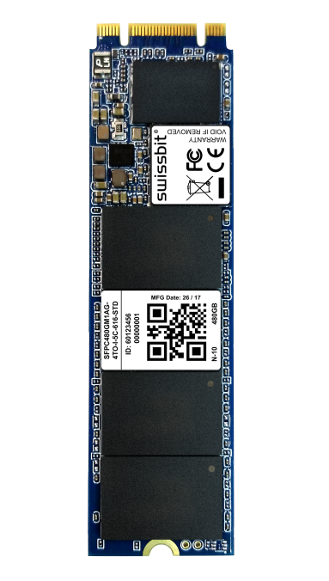  Image Source: Swissbit  Prototype of a NVMe PCIe M.2 module with low power consumption

About Swissbit AG
Swissbit is the largest independent manufacturer of embedded memory and flash storage solutions in Europe. The company was founded in 2001 through a management buy-out of Siemens AG, and has offices in Switzerland, Germany, US, Japan and Taiwan. Its main manufacturing plant in Berlin produces industrial strength flash memory products and memory cards with dedicated features for demanding applications. The Swissbit flash range includes SSDs with SATA interface as mSATA, Slim SATA, CFast™, M.2 and 2.5”, CompactFlash, USB flash drives, SD and micro SD memory cards. Swissbit offers products with long-term availability, high reliability and durability and custom optimization for demanding applications in the industrial, automotive and NetCom sectors. With its secure storage solutions, Swissbit addresses the increasing security requirements demanded by industrial, government, defense, medical, NetCom, machine-to-machine communication and finance industry segments. All Swissbit products meet the highest quality standards and the RoHS and REACH directives.
For further information, please visit www.swissbit.com
Further Information:  Swissbit AG  Silke Lüers  Industriestrasse 4  9552 Bronschhofen  Switzerland  Tel: +41 71 913 03 39  Email: silke.lueers@swissbit.com  www.swissbit.com | Media Contact:  HighTech communications GmbH  Brigitte Basilio  Grasserstrasse 1c  80339 Munich  Germany  Phone: +49 89 500778-20  Fax: +49 89 500778-77  E-mail: b.basilio@htcm.de  www.htcm.de

