PRESS RELEASE

Swissbit presents industrial eMMC EM-20
Reliable Boot Medium for Embedded Applications
Bronschhofen, Switzerland. June 1, 2017 – Swissbit, a leading manufacturer of flash memory solutions, presents its latest technology for the industrial market: the embedded Multimedia card EM-20. The eMMC combines an industrial controller with reliable multi-level cell (MLC) flash in a BGA153 package making it possible to solder the memory directly onto the printed circuit board of the target application. With capacities from 8 to 64 GB, all typical applications are covered. EM-20 replaces thus far commonly used NAND memory chips, which depend on elaborate operating system resources. Thanks to its integrated controller, flash management functionality and standardized interface, EM-20 can be easily designed-in to applications and offers a variety of key features. The firmware is designed for use as a streamlined and energy-saving boot medium for medical devices, POS/POI terminals or demanding industrial embedded computing applications. As a further distinctive feature, Swissbit's EM-20 can be optionally operated in reliable / pseudo-SLC mode (pSLC).
pSLC (pseudo Single Level Cell) stores only one bit per MLC cell. For certain applications, the pSLC mode offers important advantages: it is significantly faster than the standard use of multi-level cell flash technology and at the same time it increases the possible P/E cycles (program/erase cycles) from 3,000 to 20,000. Under the same conditions, the endurance of the data carriers increases by a factor of 6.7. The user can flexibly configure and choose between pSLC or MLC mode, even separately for different partitions if required.
Industrial temperature range
EM-20 memory cards are based on JEDEC 5.0 - the de facto standard for industrial eMMCs. They are available with capacities of 8, 16, 32, or 64 GB and offer the most advanced firmware features such as page-based flash management, wear levelling, read disturb management, data care management and secure data erasure. The Replay Protected Memory Block (RPMB), a one-time writable partition, makes key-storage for Trusted Execution Environments possible. With data-refresh-functionalities and an industrial operating temperature range from -40 °C to +85 °C, the data carrier is designed for long-term operation under harsh conditions. Swissbit’s eMMC offers highest performance with up to 270 MB/s for reading and 160 MB/s for writing.

Available images
The following images are available for download in printable format at: http://www.htcm.de/kk/swissbit
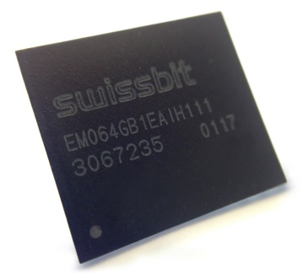
Image Source: Swissbit
New Memory-Solutions from Swissbit: the embedded Multimedia Card EM-20

About Swissbit AG
Swissbit is the largest independent manufacturer of embedded memory and flash storage solutions in Europe. The company was founded in 2001 through a management buy-out of Siemens AG, and has offices in Switzerland, Germany, US, Japan and Taiwan. Its main manufacturing plant in Berlin produces industrial strength flash memory products and memory cards with dedicated features for demanding applications. The Swissbit flash range includes SSDs with SATA interface as mSATA, Slim SATA, CFast™, M.2 and 2.5”, CompactFlash, USB flash drives, SD and micro SD memory cards. Swissbit offers products with long-term availability, high reliability and durability and custom optimization for demanding applications in the industrial, automotive and NetCom sectors. With its secure storage solutions, Swissbit addresses the increasing security requirements demanded by industrial, government, defense, medical, NetCom, machine-to-machine communication and finance industry segments. All Swissbit products meet the highest quality standards and the RoHS and REACH directives.
For further information, please visit www.swissbit.com

Further Information:  Swissbit AG  Silke Lüers  Industriestrasse 4  9552 Bronschhofen  Switzerland  Tel: +41 71 913 03 39  Email: silke.lueers@swissbit.com  www.swissbit.com | Media Contact:  HighTech communications GmbH  Brigitte Basilio  Grasserstrasse 1c  80339 Munich  Germany  Phone: +49 89 500778-20  Fax: +49 89 500778-77  Email: b.basilio@htcm.de  www.htcm.de

