PRESS RELEASE

Swissbit reaches key milestone with industrial MLC Flash Memory
MLC from an SLC-Expert
Bronschhofen (Switzerland), June 28, 2017 – Swissbit, a leading manufacturer of flash memory solutions, has reached a key milestone with its MLC technology durabit™. In December 2016, for the first time, a third of all flash products sold by Swissbit were based on MLC (Multi Level Cell). At the same time, sales of SLC products (Single Level Cell) also increased, firmly establishing Swissbit as a leading provider of industrial flash memory products. Traditionally, demanding applications in industrial, telecommunications and medical technology were the sole domain for SLC-based storage products. The innovations united under the brand name durabit™ have allowed Swissbit to successfully shift the boundaries of what is possible with MLC Flash. In the beginning, there were durabit™ SD memory cards. Now SATA 6Gb/s SSDs from the X-60 range are spreading the use of durable MLC flash memory.
"The success of durabit™ products shows that we have been successful in qualifying our optimized MLC technology for industrial applications. Compared to SLC, developers of embedded systems and robust, durable products now have access to more cost-effective memory solutions, which for many applications meet the property requirements," said Ulrich Brandt, Director of Marketing at Swissbit AG.
Key durabit™ product properties include, in particular, mechanical and electrical durability and a variety of firmware- and controller-innovations such as low WAF, extended overprovisioning and data care management. These internal mechanisms of the Swissbit memory solutions offer unrivalled values for endurance (life of the flash medium) and retention (life of stored data). Like the classic SLC media, Swissbit also offers developer support and long-term availability for its MLC products manufactured in Germany, in accordance with product life cycles in industrial, telecommunications and medical technology.

Available images
The following images are available for download in printable format at: http://www.htcm.de/kk/swissbit
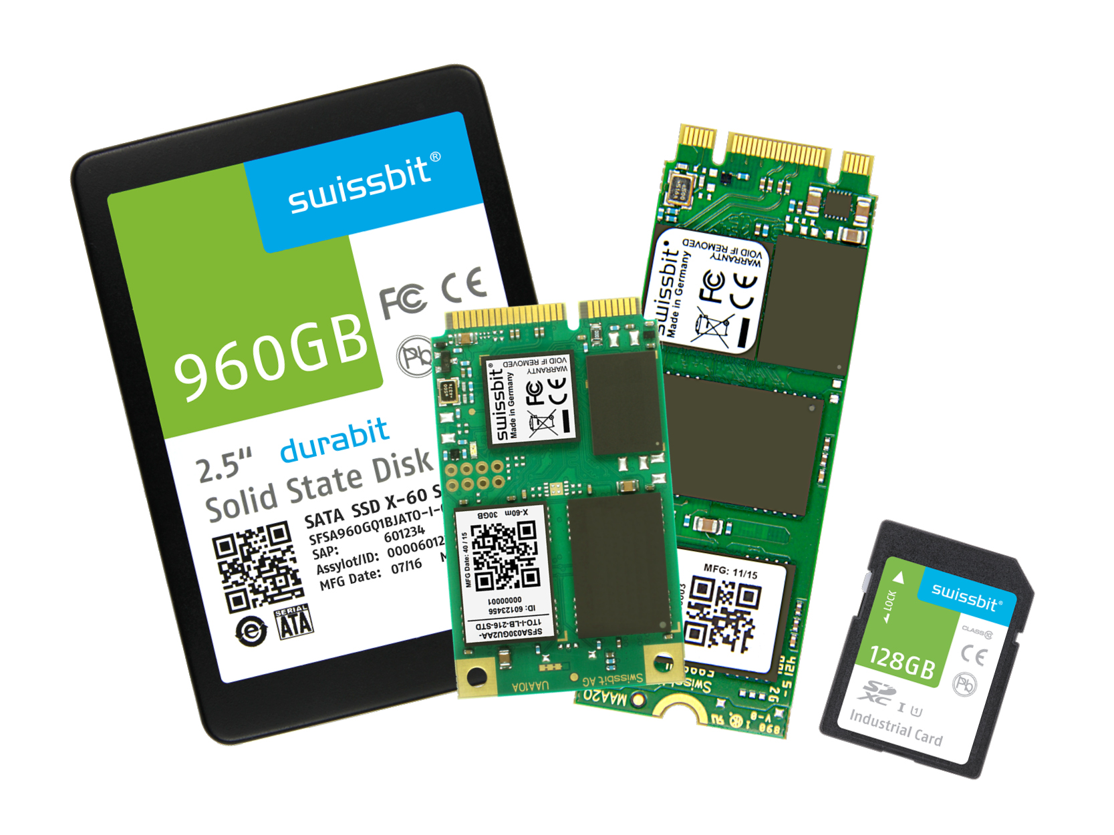
Image Source: Swissbit
MLC Flash Memory from Swissbit

About Swissbit AG
Swissbit is the largest independent manufacturer of embedded memory and flash storage solutions in Europe. The company was founded in 2001 through a management buy-out of Siemens AG, and has offices in Switzerland, Germany, US, Japan and Taiwan. Its main manufacturing plant in Berlin produces industrial strength flash memory products and memory cards with dedicated features for demanding applications. The Swissbit flash range includes SSDs with SATA interface as mSATA, Slim SATA, CFast™, M.2 and 2.5”, CompactFlash, USB flash drives, SD and micro SD memory cards. Swissbit offers products with long-term availability, high reliability and durability and custom optimization for demanding applications in the industrial, automotive and NetCom sectors. With its secure storage solutions, Swissbit addresses the increasing security requirements demanded by industrial, government, defense, medical, NetCom, machine-to-machine communication and finance industry segments. All Swissbit products meet the highest quality standards and the RoHS and REACH directives.
For further information, please visit www.swissbit.com

Further Information:  Swissbit AG  Silke Lüers  Industriestrasse 4  9552 Bronschhofen  Switzerland  Tel: +41 71 913 03 39  Email: silke.lueers@swissbit.com  www.swissbit.com | Media Contact:  HighTech communications GmbH  Brigitte Basilio  Grasserstrasse 1c  80339 Munich  Germany  Tel: +49 89 500778-20  Fax: +49 89 500778-77  Email: b.basilio@htcm.de  www.htcm.de

