PRESS RELEASE

Thanks to the Sharp-Swissbit partnership, French merchants can now meet the new legal requirements coming into force in the near future
Sharp ECR Solutions Now Comply With 2018 Fiscal Law
Paris (France), Bronschhofen (Switzerland), October 27, 2017 – Sharp, the leading manufacturer of cash registers and electronic point-of-sale terminals, announces with its partner Swissbit the introduction of solutions that comply with new French fiscal law for the retail sector: an update for 9 current Sharp cash registers and a brand new range of 9 alphanumeric cash registers now make fraud impossible.
In order to combat VAT fraud related to the concealment of revenues, French merchants and other professionals subject to VAT will be obliged, as from January 1 2018, to use a secured and certified cash register system, satisfying the legal requirements of data inalterability, security, storage and archiving.
To respond to this new legislation, Sharp now offers a fiscal update for its 9 alphanumeric cash registers offering the widest possibility of certification of the existing fleet (models XEA147BK, XEA177BK, XEA177WH, XEA207B, XEA207W, XEA217B, XEA307W, ERA411, ERA421, and in October 2017, UP3515.)
A Sharp-Swissbit fiscal solution offers a very high level of security
- With a special Write Once Read Multiple (WORM) SD card for security applications used as storage media, the user's fiscal records are ready for inspection either locally or remotely by digitally signed secure archives.
- The cash register can not perform any transactions until the SD WORM card is inserted, which ensures that all transactions are recorded. In addition, the SD card is permanently and cryptographically linked to the cash register on which it was initialized. The origin of the data is therefore absolutely certain for the tax administration.
- All transactions are recorded on the SD card upon issuing of a receipt. And no transaction is lost, even in the event of a breakdown.
- The use of WORM flash cards is also reliable because the content stored in the card can not be deliberately or unintentionally modified or deleted.
- A digital signature with the ECDSA 521-bit algorithm makes it possible to safely archive data as required by law without risk of manipulation. Such a hardware based security solution is superior to softward based solutions, which may require regular re-auditing after each software update.
In parallel, Sharp announced last June the commercialization of a new range of 9 certified cash registers: 7 models of XEA range: XEA147BKSF, XEA177BKSF, XEA177WHSF, XEA207BSF, XEA207WSF, XEA217BSF, XEA307SF and 2 models of ERA range: ERA411SF and ERA421SF.
Merchants and users of Sharp cash registers thus have an integrated system that optimally secures and archives data, is as intuitive as the use of a SIM-Card and does not slow down the payment process.
"Thanks to the Sharp fiscal update, our ECR systems are a reliable and lasting solution for thousands of professionals in France. Catering and hotel merchants using the Sharp certification scheme or investing in new certified solutions will fully meet the legal and legislative requirements that will come into force in early 2018", said Nathalie Chamblain, Sharp Business Systems Southern Europe Marketing Director at Sharp France.
Sharp has been a manufacturer of electronic cash registers and electronic point-of-sale terminals for more than 30 years and has one of the largest range on the market and has products that meet the needs of any retail business.
"Given its extreme performance, we expect the solution to be well received in the market. All legally required processes take place automatically on the card in less than 20 ms after data transfer. The sales transaction is not slowed down by the process, which was a major problem for cash registers in the eyes of customers until then " explains Hubertus Grobbel, Swissbit.

Available images
The following images are available for download in printable format at: http://www.htcm.de/kk/swissbit
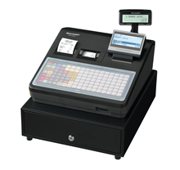  Image Source: Sharp  Thanks to the cooperation with Swissbit: Certified cash register systems from Sharp that satisfy fiscal regulations for the prevention of VAT-fraud that will come into force from 2018 in France. | 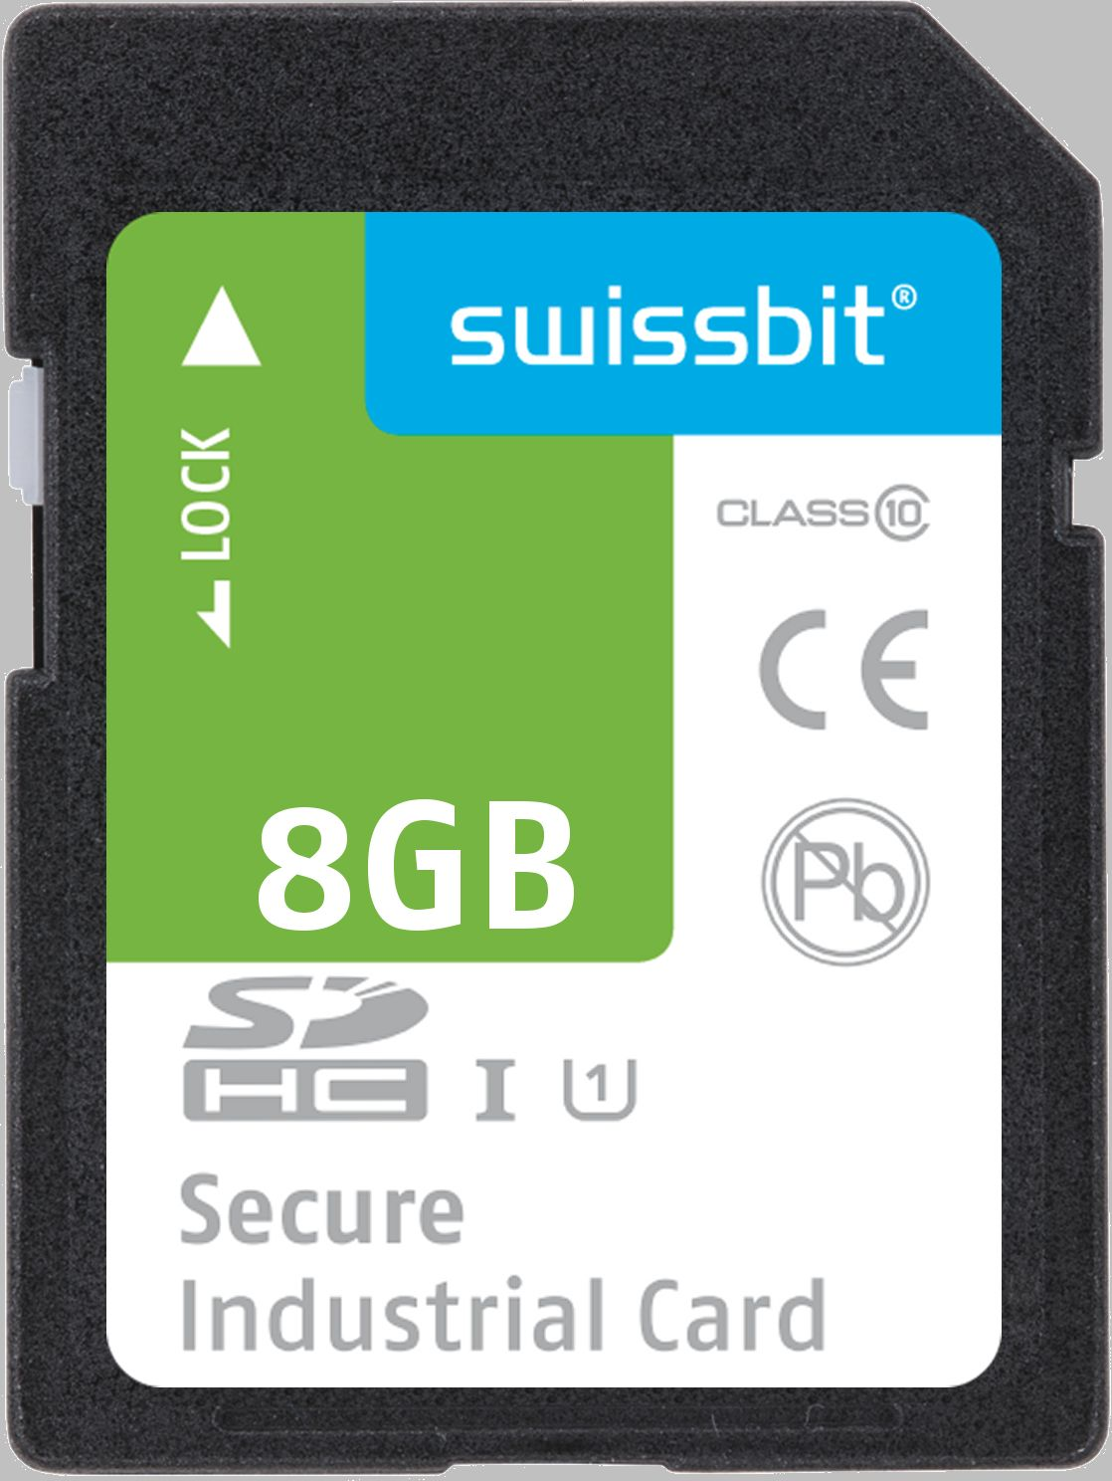  Image Source: Swissbit  This is how invoice data is archived for fraud-prevention: SD Memory Cards from Swissbit with WORM- and security-functions.

About Sharp Cash Management Solutions
Sharp has been innovating in cash registers and payment solutions for more than 30 years. Sharp offers a complete range of POS solutions, from compact digital checkout to point-of-sale solutions with the most sophisticated color touch screen. Many customers around the world have trusted the quality and reliability of Sharp POS solutions. That's why Sharp is a recognized partner for points of sale, hotels and restaurants.
For further information, please visit www.sharp.fr

About Swissbit AG
Swissbit is the largest independent manufacturer of embedded memory and flash storage solutions in Europe. The company was founded in 2001 through a management buy-out of Siemens AG, and has offices in Switzerland, Germany, US, Japan and Taiwan. Its main manufacturing plant in Berlin produces industrial strength flash memory products and memory cards with dedicated features for demanding applications. The Swissbit flash range includes SSDs with SATA interface as mSATA, Slim SATA, CFast™, M.2 and 2.5”, CompactFlash, USB flash drives, SD and micro SD memory cards. Swissbit offers products with long-term availability, high reliability and durability and custom optimization for demanding applications in the industrial, automotive and NetCom sectors. With its secure storage solutions, Swissbit addresses the increasing security requirements demanded by industrial, government, defense, medical, NetCom, machine-to-machine communication and finance industry segments. All Swissbit products meet the highest quality standards and the RoHS and REACH directives.
For further information, please visit www.swissbit.com

Further Information:  Swissbit AG  Silke Lüers  Industriestrasse 4  9552 Bronschhofen  Switzerland  Tel: +41 71 913 03 39  Email: silke.lueers@swissbit.com  www.swissbit.com | Media Contact:  HighTech communications GmbH  Brigitte Basilio  Brunhamstrasse 21  81249 Munich  Germany  Tel: +49 89 500778-20  Fax: +49 89 500778-77  Email: b.basilio@htcm.de  www.htcm.de

