PRESS RELEASE
November 13-16, 2018
Hall B5, Booth 420


Swissbit at electronica 2018
System security and data protection by design
Bronschhofen, Switzerland. October 17, 2018 – Swissbit AG, a leading manufacturer of industrial-grade flash memory solutions, will be exhibiting at electronica 2018 (November 13–16 2018, Hall B5, Booth 420, Messe Munich). This year’s theme will be focused around security solutions: Swissbit memory cards and USB-sticks with encryption functions within the firmware and integrated Secure Element that can serve as an upgradable protected key storage for system security. One product-highlight will be Swissbit’s PU-50n DP, a robust USB-stick with internal AES-256-bit encryption, access-protection and optional ROM/WORM function. Further show highlights will be an industrial-grade 3D-NAND flash memory and the partnership-projects for system-in-package development.
A USB-stick as a component of security solutions: PU-50n DP has an internal AES-256-bit encryption, password protection and offers a configurable repeat counter. On this USB 3.1-mass-storage-device, different independent partitions, for example as ROM or WORM memory, and any read and write permissions can be defined. This is comparable to the Swissbit memory cards that are deployed in police bodycams or in tamper-proof cash registers, which will be presented as application examples at the electronica booth as well.
The manufacturer will demonstrate opportunities for system security in the IIoT using the concept of a net-policy-server for control and management of flash memory as an authentication token and boot device. This allows a two-factor authentication to be linked to one IP-address so that a boot loader will only function within a defined network.
On Swissbit's electronica booth, secure booting of a RaspBerry Pi will be showcased: here, the administrator can differentiate between various policies that determine the approval of memory access. The memory can only be used with the right device, by the right person, within the right network and with a specific license token or the right boot software.
3D-NAND for harsh conditions
Furthermore, Swissbit will show two examples for 3D-NAND based memory products suited for industrial temperature ranges: Swissbit X-75 is a SATA-6-Gb/s-SSD for use between -40 and +85 °C. Before the end of the year, the 2.5” SSD will be launched in different versions, ranging from 60 GB to 2 TB. With its low power consumption, the NVMe PCIe M.2-module N-10m2 is particularly suited for use with fanless systems.
SiP production in Berlin
Swissbit offers development partnerships for production of SiPs, MCPs and COBs. At its electronica booth, the company will present an example of a project that required the manufacture of specially hardened security solutions. Swissbit provides cutting-edge production and testing facilities in Berlin and continues to expand them.

Available images
The following images are available for download in printable format at: http://www.htcm.de/kk/swissbit
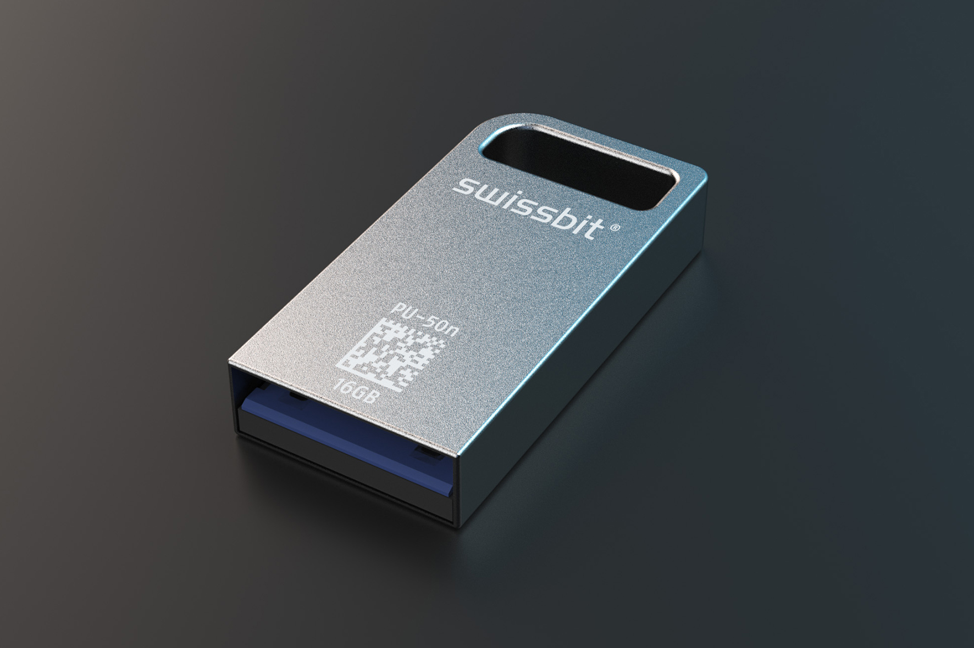  Image Source: Swissbit  Product highlight at electronica 2018: USB stick PU-50n DP with internal AES-256-bit encryption, access protection and optional ROM/WORM function. | 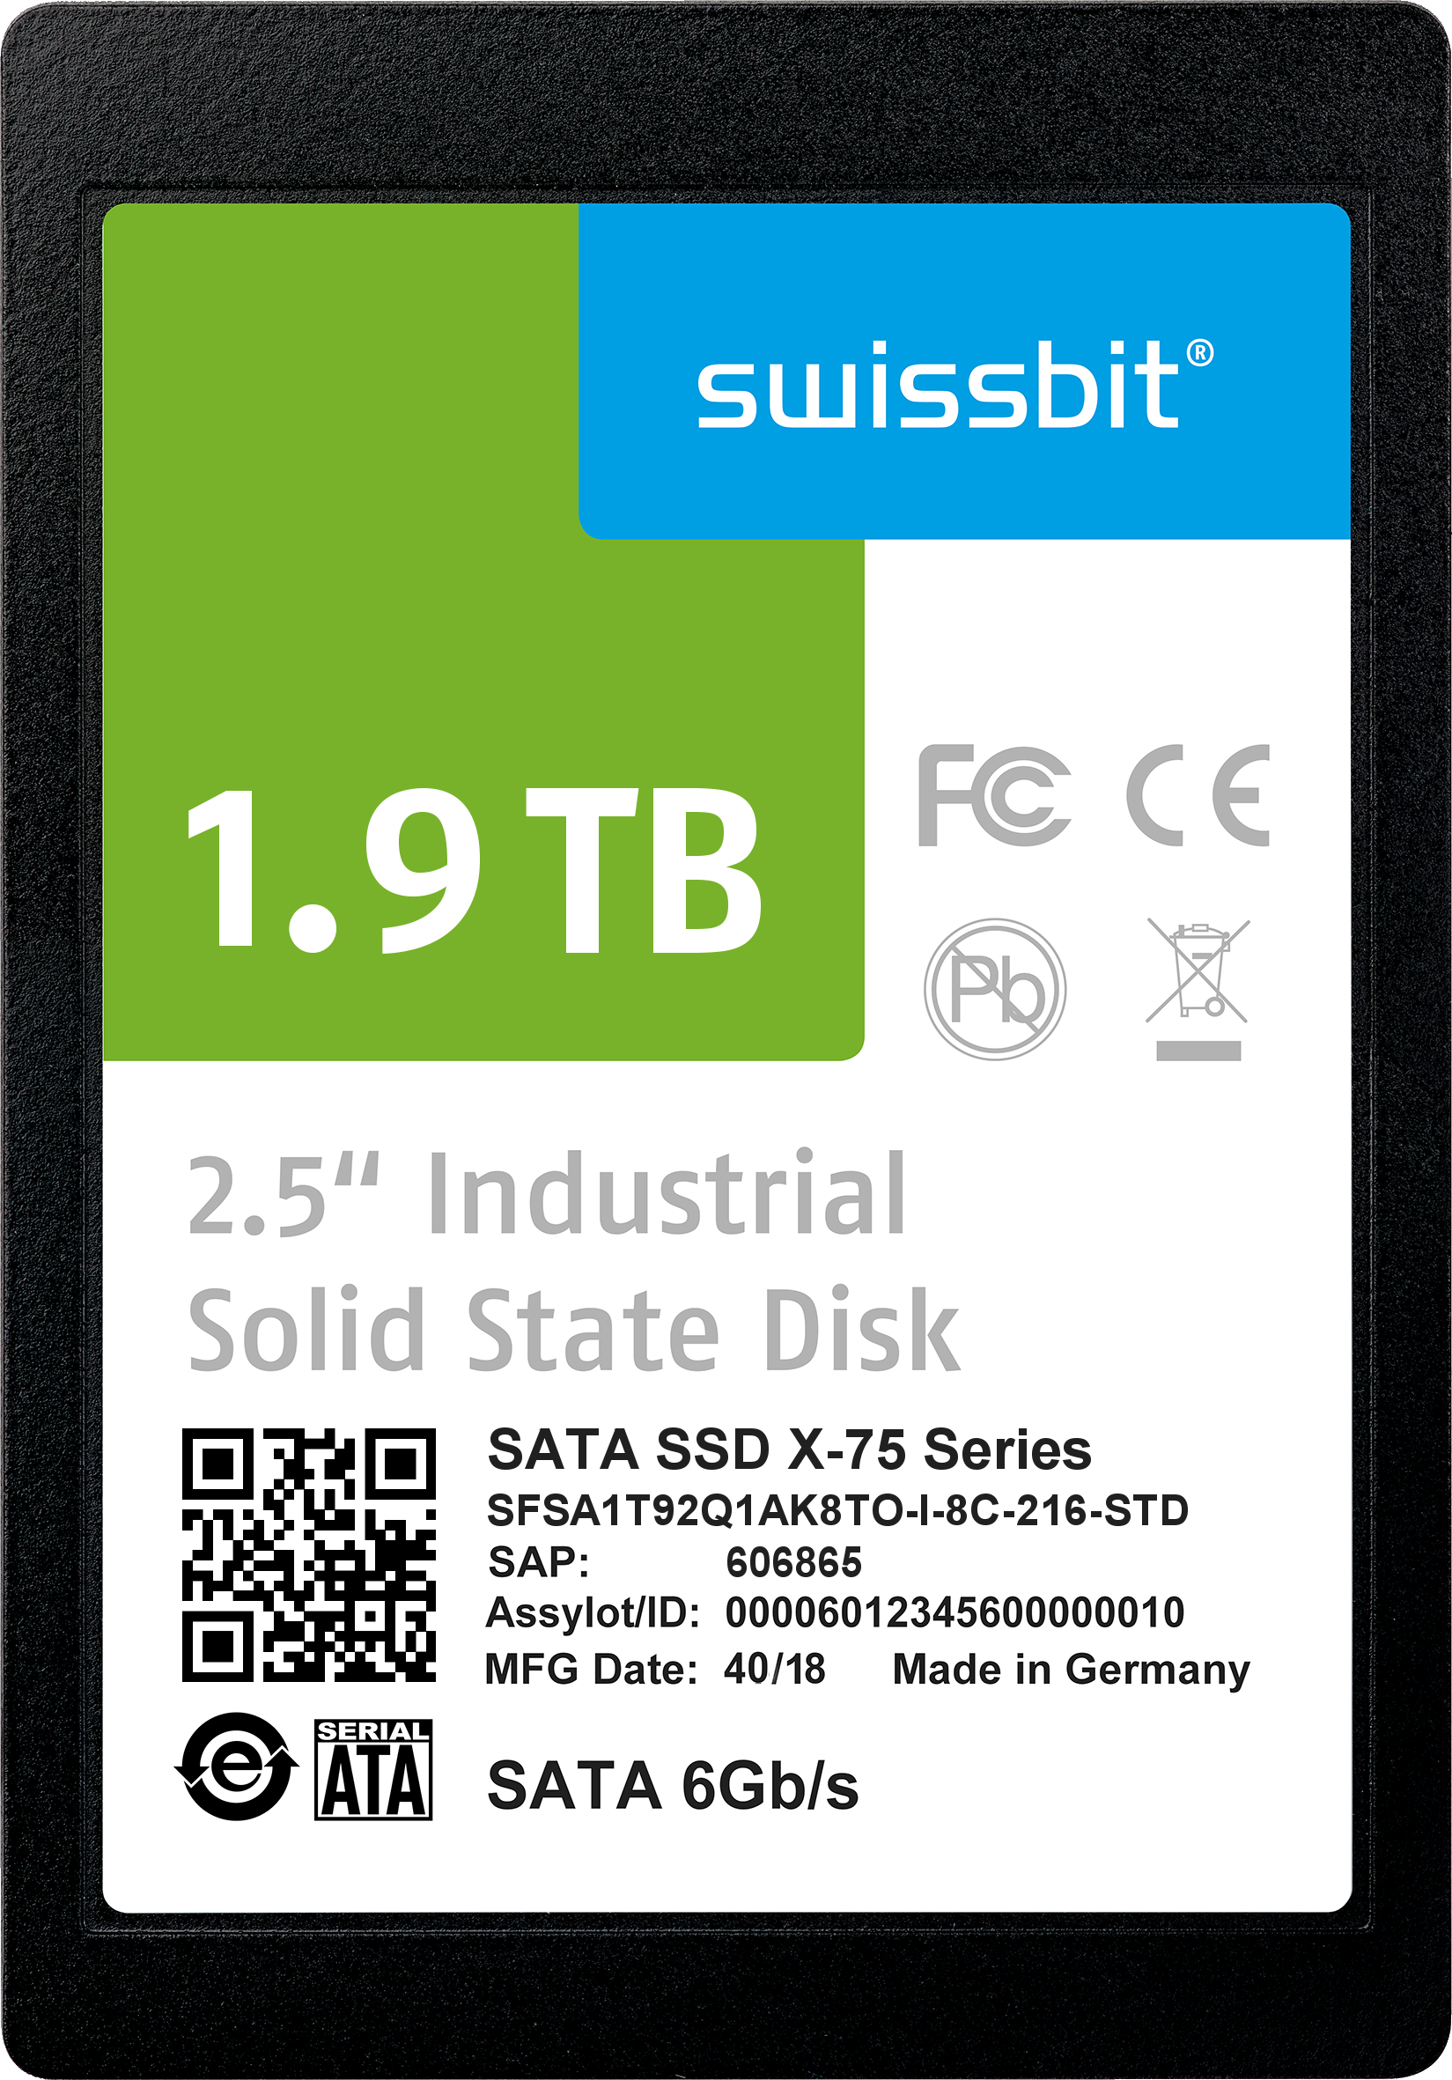  Image Source: Swissbit  3D NAND based memory product with industrial temperature range: Swissbit X-75 is a SATA-6-Gb/s-SSD for use between -40 and +85 °C.

About Swissbit AG
Swissbit is the largest independent manufacturer of embedded memory and flash storage solutions in Europe. The company was founded in 2001 through a management buy-out of Siemens AG, and has offices in Switzerland, Germany, US, Japan and Taiwan. Its main manufacturing plant in Berlin produces industrial strength flash memory products and memory cards with dedicated features for demanding applications. The Swissbit flash range includes SSDs with SATA interface as mSATA, Slim SATA, CFast™, M.2 and 2.5”, CompactFlash, USB flash drives, SD and micro SD memory cards. Swissbit offers products with long-term availability, high reliability and durability and custom optimization for demanding applications in the industrial, automotive and NetCom sectors. With its secure storage solutions, Swissbit addresses the increasing security requirements demanded by industrial, government, defense, medical, NetCom, machine-to-machine communication and finance industry segments. All Swissbit products meet the highest quality standards and the RoHS and REACH directives.
For further information, please visit www.swissbit.com

Contact:  Swissbit AG  Silke Lüers  Industriestrasse 4  9552 Bronschhofen  Switzerland  Tel: +41 71 913 03 39  Email: silke.lueers@swissbit.com  www.swissbit.com | Press Agency:  miXim Ltd.  Kim Sauer (Mr)  Tel: +44 7906 019 022  Email: kim@miXimPR.com

