PRESS RELEASE


Swissbit to exhibit at embedded world 2019
Memory card enabled security
26–28 February 2019
Hall 1, Booth 1-534
Bronschhofen, Switzerland. January 17, 2019 - Swissbit AG, a leading manufacturer of industrial-grade flash memory solutions, will be highlighting its security solutions at embedded world, which will be taking place from 26-28 February 2019 in Nuremberg, Germany. In Hall 1 Booth # 1-534, Swissbit will be presenting memory cards and USB sticks with firmware-embedded cryptographic features and integrated secure element that enable secure boot or authentication- and encryption-applications. Swissbit recommends the concept as it not only offers much greater security than simple software solutions but is also future-proof and more flexible than soldered TPM (Trusted Platform Memory) products. A key product highlight will be Swissbit’s PU-50n DP, a durable USB stick with internal AES-256-bit encryption, access protection and optional ROM/WORM function.
For Industry 4.0 applications, Swissbit will be introducing the concept of a net-policy-server for control and management of flash memory as an authentication token and boot device. This allows two-factor authentication to be linked to one IP-address so that a boot loader will only function within a defined network. At embedded world, Swissbit will demonstrate this with a RaspBerry Pi: the administrator can differentiate between various policies that determine the approval of memory access according to set criteria. The memory can only be accessed by the right person on the right device, within the right network. Only after successful authentication, the secure boot code is enabled by the storage medium. In case of loss, Swissbit Cloud Service can easily lock the encrypted PU-50n DP. To avoid the risk of insecure passwords, the SmartCard within the PU-50n PE acts as a high-security authentication token. Recent cases of data leaks in Germany have once again proven that passwords are not secure.
State-of-the-art memory technology
As an example of a 3D NAND-based memory product designed for industrial temperature ranges, Swissbit will be presenting its NVMe PCIe M.2 module N-10m2 at the show. It is particularly suitable for use in fanless systems due to being optimized for low power consumption. Swissbit will also be reviving a seemingly ‘outdated’ flash memory format with state-of-the-art technology with its CompactFlash™ product lines C-500, C-56 and C-50. As a format that is pretty much obsolete in information and communication technology, it is still very much in high demand for many industrial applications. With its solution, Swissbit scores highly by ensuring long-term availability.

Available images
The following images are available for download in printable format at: http://www.htcm.de/kk/swissbit
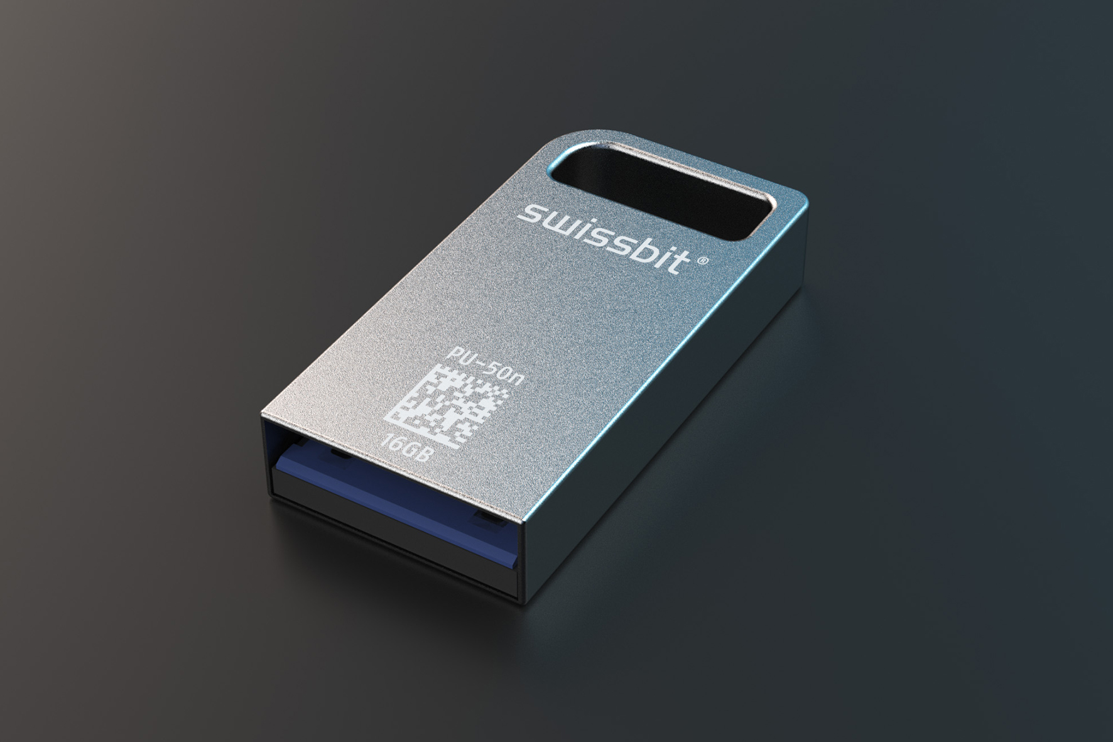
Image Source: Swissbit
Product highlight at embedded world 2019: USB stick PU-50n DP with internal AES-256-bit encryption, access protection and optional ROM/WORM function.

About Swissbit AG
Swissbit is the largest independent manufacturer of embedded memory and flash storage solutions in Europe. The company was founded in 2001 through a management buy-out of Siemens AG, and has offices in Switzerland, Germany, US, Japan and Taiwan. Its main manufacturing plant in Berlin produces industrial strength flash memory products and memory cards with dedicated features for demanding applications. The Swissbit flash range includes SSDs with SATA interface as mSATA, Slim SATA, CFast™, M.2 and 2.5”, CompactFlash, USB flash drives, SD and micro SD memory cards. Swissbit offers products with long-term availability, high reliability and durability and custom optimization for demanding applications in the industrial, automotive and NetCom sectors. With its secure storage solutions, Swissbit addresses the increasing security requirements demanded by industrial, government, defense, medical, NetCom, machine-to-machine communication and finance industry segments. All Swissbit products meet the highest quality standards and the RoHS and REACH directives.
For further information, please visit www.swissbit.com

Contact:  Swissbit AG  Silke Lüers  Industriestrasse 4  9552 Bronschhofen  Switzerland  Tel: +41 71 913 03 39  Email: silke.lueers@swissbit.com  www.swissbit.com | Press Agency:  HighTech communications GmbH  Brigitte Basilio  Brunhamstrasse 21  81249 Munich  Germany  Tel: +49 89 500778-20  Fax: +49 89 500778-77  Email: b.basilio@htcm.de  www.htcm.de

