PRESS RELEASE

Swissbit introduces USB 3.1 sticks
Mobile, designed for industrial use and secure
Bronschhofen (Switzerland), May 29, 2018 – Swissbit is pleased to announce the introduction of a new product range of USB 3.1 flash drives. The new USB sticks fulfill the tough requirements of flash memory for industrial use. The series is based on a highly sophisticated USB 3.1 flash controller and comprises the product range U-500k with a highly reliable SLC-NAND and U-50k with MLC-NAND. Furthermore, a version with MLC-NAND in pSLC configuration is offered under the name U-56k. The benefit: an endurance seven times longer than that of a MLC-NAND with the same memory density. By the third quarter of 2018, the SLC versions with densities of 2 to 32 GB, the MLC version with 16 to 128 GB and the pSLC configuration with 8 to 64 GB will be available. Particularly important considering the new stricter data protection provisions: all USB 3.1 sticks are also offered in versions with integrated data protection features.
USB flash drives are often used to transport data between different locations or as exchangeable memory expansion in industrial applications such as log data storage, data backup, system upgrade or as license token. Now Swissbit offers new USB stick ranges that fulfill the same requirements for professional applications as other industrial storage solutions yet are extremely easy to use and universally applicable.
Firmware for smart memory chip usage
In combination with the SuperSpeed USB 3.1 interface, U-500k, U-50k and U-56k offer outstanding data rates for the sequential writing of data. As the firmware works with page-based mapping, the random-write IOPS performance increases, while wear decreases significantly. This in turn makes USB sticks the perfect solution for data logging applications. Smart firmware routines recognize weak data segments and update them before any data loss occurs. This is particularly important when used as boot medium or for long-term data storage.
Security and data protection
Swissbit will offer special variants of these USB sticks for confidential or license-relevant content under the names PU-500k, PU-50k and PU-56k. Configurable security options allow for data encryption and access restrictions with PIN protection including repeat counter and hidden or read-only partitions. The data protection option “DP” prevents data from being spied upon in case of loss or theft of a flash drive. Furthermore, the secured USB stick can also be employed as copy-protected license tokens.
Proven casing
For the new USB 3.1 product range, Swissbit AG once again has opted for their proven flash drive casing “unitedCONTRAST II”, already used for their USB 2.0 sticks, which is also available in customized designs. Additionally, Swissbit will add a “Nano” casing to their range - a robust flash drive in an enclosed tamper-proof metal casing.

Available images
The following images are available for download in printable format at: http://www.htcm.de/kk/swissbit
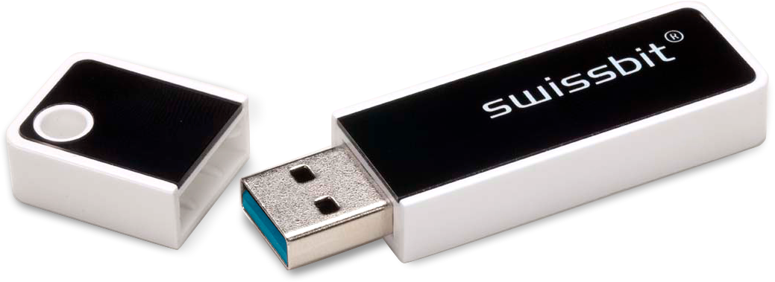
Image Source: Swissbit
U-500k in industrial use casing.

About Swissbit AG
Swissbit is the largest independent manufacturer of embedded memory and flash storage solutions in Europe. The company was founded in 2001 through a management buy-out of Siemens AG, and has offices in Switzerland, Germany, US, Japan and Taiwan. Its main manufacturing plant in Berlin produces industrial strength flash memory products and memory cards with dedicated features for demanding applications. The Swissbit flash range includes SSDs with SATA interface as mSATA, Slim SATA, CFast™, M.2 and 2.5”, CompactFlash, USB flash drives, SD and micro SD memory cards. Swissbit offers products with long-term availability, high reliability and durability and custom optimization for demanding applications in the industrial, automotive and NetCom sectors. With its secure storage solutions, Swissbit addresses the increasing security requirements demanded by industrial, government, defense, medical, NetCom, machine-to-machine communication and finance industry segments. All Swissbit products meet the highest quality standards and the RoHS and REACH directives.
For further information, please visit www.swissbit.com

Further Information:  Swissbit AG  Silke Lüers  Industriestrasse 4  9552 Bronschhofen  Switzerland  Tel: +41 71 913 03 39  Email: silke.lueers@swissbit.com  www.swissbit.com | Media Contact:  HighTech communications GmbH  Brigitte Basilio  Brunhamstrasse 21  81249 Munich  Germany  Tel: +49 89 500778-20  Fax: +49 89 500778-77  Email: b.basilio@htcm.de  www.htcm.de

