PRESS RELEASE

Groundbreaking ceremony to triple Swissbit production capacity
Expansion of Flash Memory Production in Berlin kick-started
Bronschhofen (Switzerland), Berlin (Germany), August 27, 2018 – Construction has begun on Swissbit’s new R&D and manufacturing facility. All of the company’s flash memory products are exclusively produced in Germany. A symbolic groundbreaking ceremony on 31 July 2018 initiated the planned tripling of the production capacity at the CleanTech Business Park location in Berlin-Marzahn, Germany.
The ceremony was presided by Swissbit CEO Silvio Muschter who was joined by Mr Naumann (MRT GmbH), Kathrin Kanzler-Tullio (Chamber of Industry and Commerce), Christine Proksch (Swissbit Germany AG), Michael Herzog (Branch Manager Goldbeck) and Johannes Martin (District Councilor & Head of Department for Economics, Roads and Green Spaces).
The substantial expansion in capacity for the leading European manufacturer of flash memory solutions is driven by great demand for industrial memory products. In particular, memory cards with security functions, demanded by applications requiring data encryption - for example IIoT- and Industry 4.0-applications - are expected to roll off the new production lines.

Available images
The following images are available for download in printable format at: http://www.htcm.de/kk/swissbit

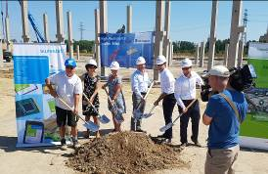  Image Source: Swissbit  Groundbreaking ceremony for the new Swissbit manufacturing plant with Mr Naumann (MRT GmbH), Kathrin Kanzler-Tullio (Chamber of Industry and Commerce), Christine Proksch (Swissbit Germany AG), Silvio Muschter (CEO Swissbit AG), Michael Herzog (Branch Manager Goldbeck) and Johannes Martin (District Councilor & Head of Department for Economics, Roads and Green Spaces). (left to right) | 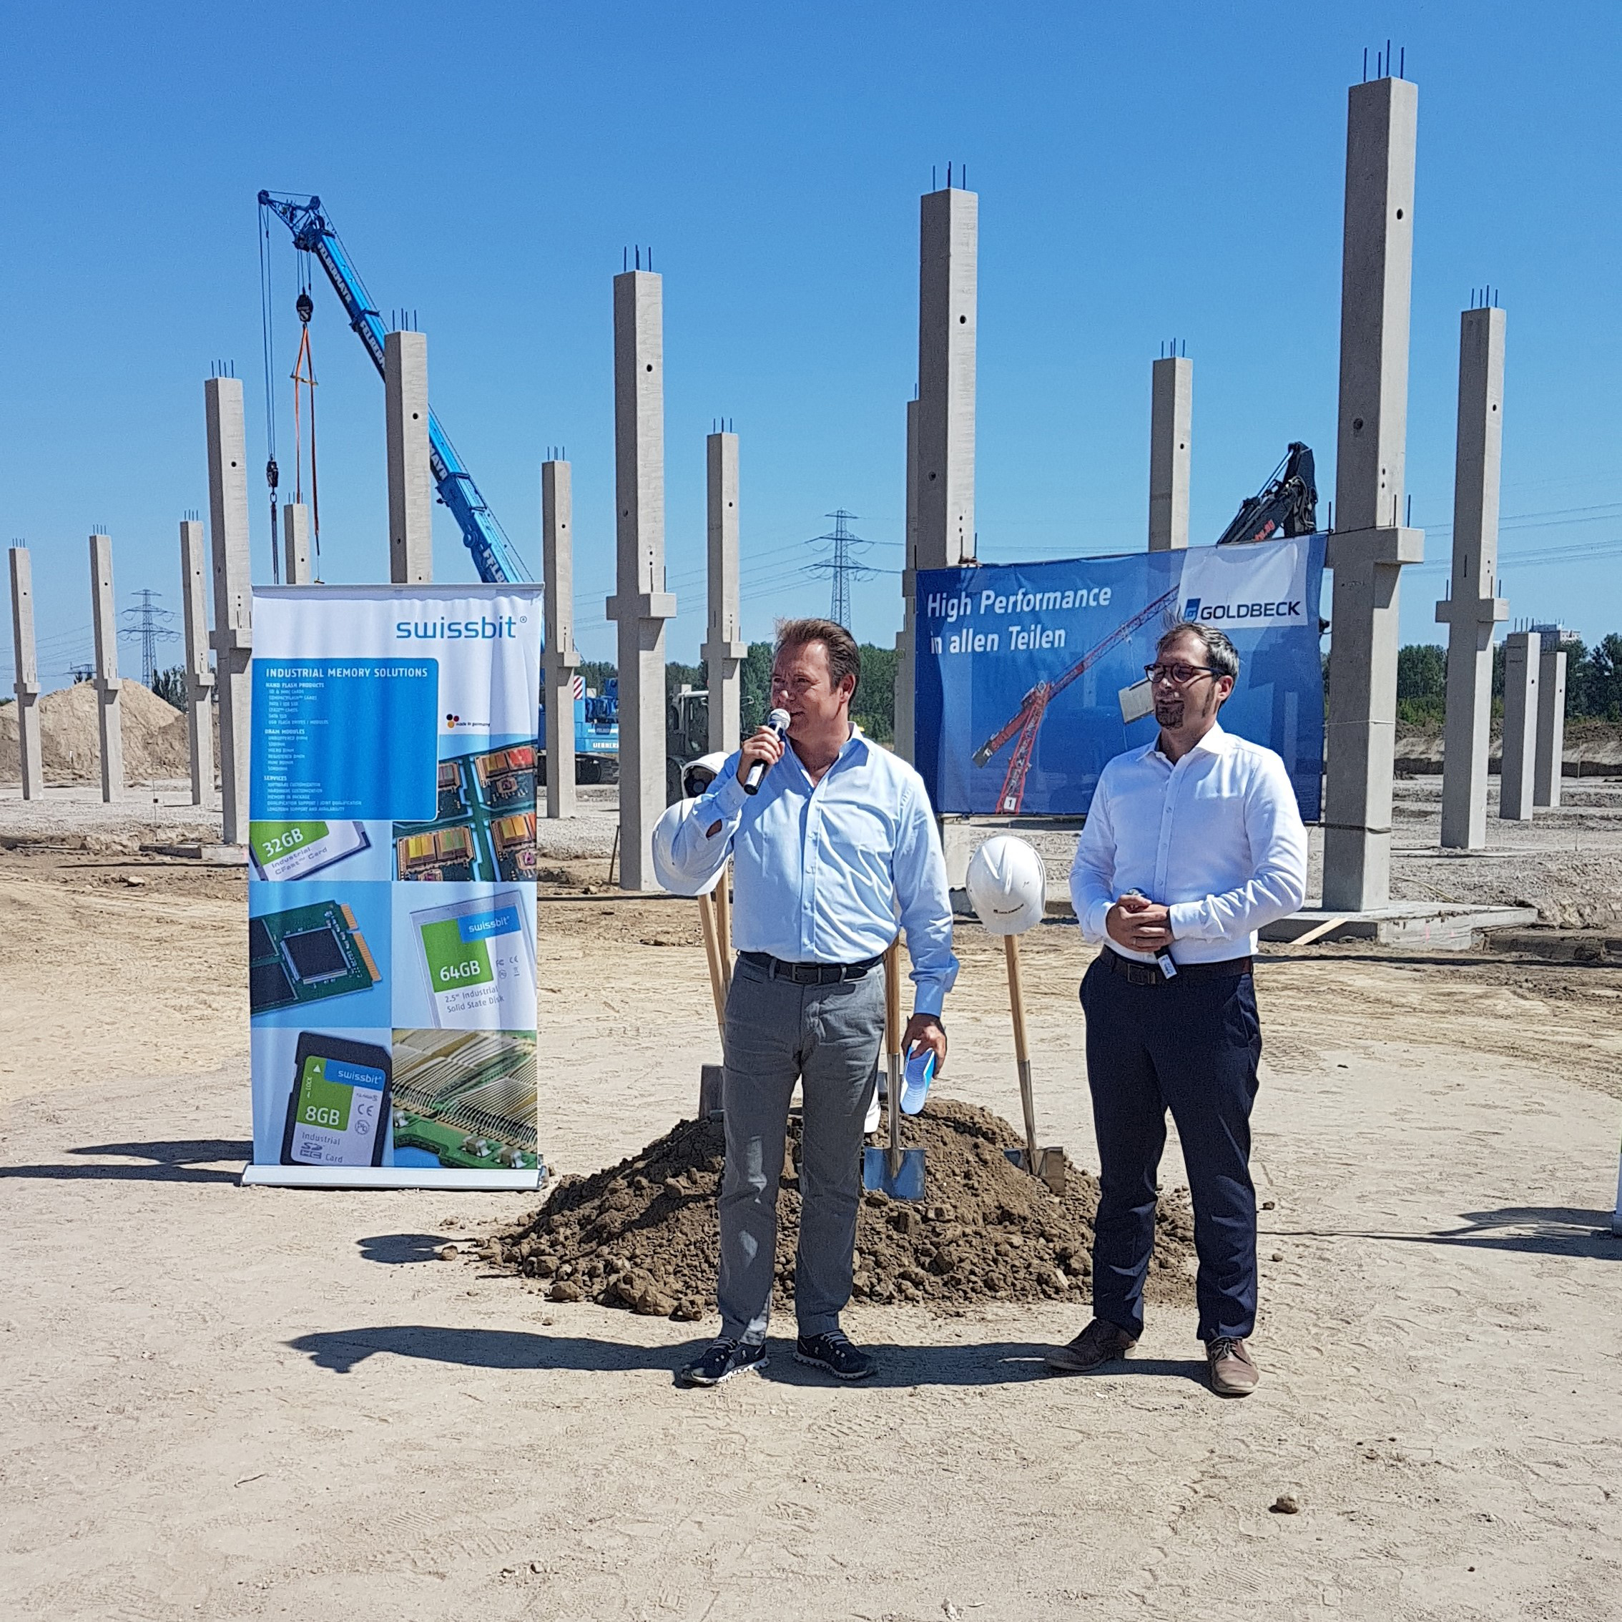  Image Source: Swissbit  Silvio Muschter (CEO, Swissbt AG) and Johannes Martin, District Councilor & Head of Department for Economics, Roads and Green Spaces, ceremoniously initiate the construction of the new Swissbit manufacturing plant.

About Swissbit AG
Swissbit is the largest independent manufacturer of embedded memory and flash storage solutions in Europe. The company was founded in 2001 through a management buy-out of Siemens AG, and has offices in Switzerland, Germany, US, Japan and Taiwan. Its main manufacturing plant in Berlin produces industrial strength flash memory products and memory cards with dedicated features for demanding applications. The Swissbit flash range includes SSDs with SATA interface as mSATA, Slim SATA, CFast™, M.2 and 2.5”, CompactFlash, USB flash drives, SD and micro SD memory cards. Swissbit offers products with long-term availability, high reliability and durability and custom optimization for demanding applications in the industrial, automotive and NetCom sectors. With its secure storage solutions, Swissbit addresses the increasing security requirements demanded by industrial, government, defense, medical, NetCom, machine-to-machine communication and finance industry segments. All Swissbit products meet the highest quality standards and the RoHS and REACH directives.
For further information, please visit www.swissbit.com

Further Information:  Swissbit AG  Silke Lüers  Industriestrasse 4  9552 Bronschhofen  Switzerland  Tel: +41 71 913 03 39  Email: silke.lueers@swissbit.com  www.swissbit.com | Media Contact:  HighTech communications GmbH  Brigitte Basilio  Brunhamstrasse 21  81249 Munich  Germany  Tel: +49 89 500778-20  Fax: +49 89 500778-77  Email: b.basilio@htcm.de  www.htcm.de

