PRESS RELEASE
Swissbit S-450 SD memory card survives high-temperature bake
Swissbit SD memory card in “Deep Well Imaging” project
Bronschhofen, Switzerland. September 25, 2018 – Swissbit AG, a leading manufacturer of industrial-grade flash memory solutions, provided a 32GB S-450 SD memory card to Hitwell Deep Well Imaging, Inc to test “High-Temperature Grade” video usability.
In order to simulate conditions of a high-pressure/high-temperature well imaging project and to test the robustness of the SD storage device, the engineers at Hitwell first loaded a 32GB S-450 from Swissbit with pseudo-random data up to full capacity. The true test was when they “baked” the card for more than 60 hours at 325°F (165°C). After cooling the SD device, it looked normal except for an insignificant minor deformation of the shell. Inserted into a reader, it was recognized as a drive without fail, and all of the original data remained fully intact. The “SD card test” recording took place in a commercial oven where the “storage data” was a non-factor to a well client.
For the “real-time” client project, the SD memory card will be placed inside the internal camera assembly. The camera will shut-down after taking the client’s well images, but then will remain downhole for an extended time. Although the camera protects its electronics with a vacuum flask which slows down the flow of heat, the SD memory card will remain exposed to high temperatures of up to 325°F (165°C) for as much as 60 hours. After retrieval of the data, the card will finally be disposed of.
Although the tested temperature range is well outside of the card’s standard specification (-40°C to 85°C), the results prove the impressive robustness and data retention of the Swissbit SD memory card. Due to the full molding of the inlay of the card, the external deformation of the shell does not affect the inner data structure of the card.

Available images
The following images are available for download in printable format at: http://www.htcm.de/kk/swissbit
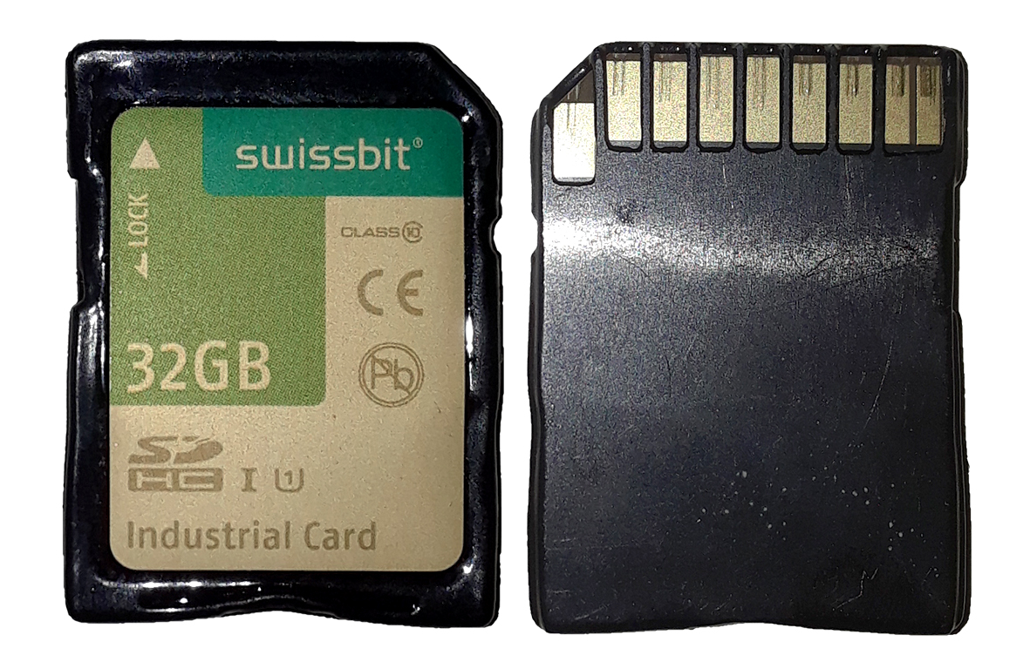
Image Source: Swissbit

Swissbit 32GB SD Memory Card successfully withstands more than 60-hour exposure to 325°F (165°C)

About Hitwell Deep Well Imaging, Inc
Hitwell Deep Well Imaging (Lexington, KY, USA) is a design/manufacturing, sales and service company which produces high-temperature, high-pressure “downhole” camera systems for oil, gas and geothermal wells. They strive to create the best downhole camera systems through research and constant development of new video technologies and well survey techniques. Hitwell collaborates with their clients, customers and colleagues in the oil/gas/geothermal industries on projects to advance mechanical inspection techniques and well integrity.
For further information, please visit www.hitwellvideo.com

About Swissbit AG
Swissbit is the largest independent manufacturer of embedded memory and flash storage solutions in Europe. The company was founded in 2001 through a management buy-out of Siemens AG, and has offices in Switzerland, Germany, US, Japan and Taiwan. Its main manufacturing plant in Berlin produces industrial strength flash memory products and memory cards with dedicated features for demanding applications. The Swissbit flash range includes SSDs with SATA interface as mSATA, Slim SATA, CFast™, M.2 and 2.5”, CompactFlash, USB flash drives, SD and micro SD memory cards. Swissbit offers products with long-term availability, high reliability and durability and custom optimization for demanding applications in the industrial, automotive and NetCom sectors. With its secure storage solutions, Swissbit addresses the increasing security requirements demanded by industrial, government, defense, medical, NetCom, machine-to-machine communication and finance industry segments. All Swissbit products meet the highest quality standards and the RoHS and REACH directives.
For further information, please visit www.swissbit.com

Further Information:  Swissbit AG  Silke Lüers  Industriestrasse 4  9552 Bronschhofen  Switzerland  Tel: +41 71 913 03 39  Email: silke.lueers@swissbit.com  www.swissbit.com | Media Contact:  HighTech communications GmbH  Brigitte Basilio  Brunhamstrasse 21  81249 Munich  Germany  Tel: +49 89 500778-20  Fax: +49 89 500778-77  Email: b.basilio@htcm.de  www.htcm.de

