PRESS RELEASE
Swissbit Promotes Grady Lambert to General Manager of North American Operations
Bronschhofen, Switzerland, Port Chester, January 10, 2019 – Swissbit AG, a leading manufacturer of industrial-grade flash memory solutions, is strengthening its successful North American business. Swissbit is pleased to announce the promotion of Grady Lambert to General Manager of its North American subsidiary, Swissbit NA Inc. The manufacturer has offices in Campbell (CA), Eagle (ID), Houston (TX), Westford (MA) and Port Chester (NY). Since 2014 Lambert has served as Technical Business Development Manager and Director of Business Development at the company’s R&D location in Westford overseeing development of Swissbit’s successful SSD product range.
In addition to leading Swissbit’s North American product and business development activities, Lambert will oversee all North American sales and marketing activities.
“Since joining Swissbit, Grady has shown the personal commitment and leadership skills necessary to take our North American division to the next level,” said Silvio Muschter, CEO Swissbit. “In his new role as General Manager, I am confident he will further Swissbit’s brand as a leading supplier of embedded storage products and services.”
Serving the US market with lowest Total Cost of Ownership (TCO) products
Swissbit enjoys a strong presence and great success in NetCom, industrial and automotive markets with its durable, extremely robust and temperature-resistant storage solutions that offer guaranteed long-term availability and lowest TCO. Lambert intends to continue to expand the consistent double-digit US-market growth rate trend achieved by the highly specialized storage manufacturer to date.
"As the embedded storage market begins its adoption of 3D NAND technology, NetCom and industrial customers trust Swissbit to deliver not only exceptional product quality and reliability, but they have come to know and value our world-wide team of talented professionals dedicated to providing the very best customer support and service.
Our growth targets in the America’s are ambitious, but we are confident that there is great and untapped demand for our solutions, especially for applications within high growth markets such as IIoT and NetCom" says Grady Lambert.

"With the development of our own innovative firmware and security features, our storage solutions offer a clear competitive advantage which is further strengthened through the provision of flexibility and long-term availability which are critical for developers and manufacturers of industrial solutions."
Prior to joining Swissbit in 2014, Lambert held technical leadership positions at SMART Modular and Centennial Technologies.

Available images
The following images are available for download in printable format at: http://www.htcm.de/kk/swissbit
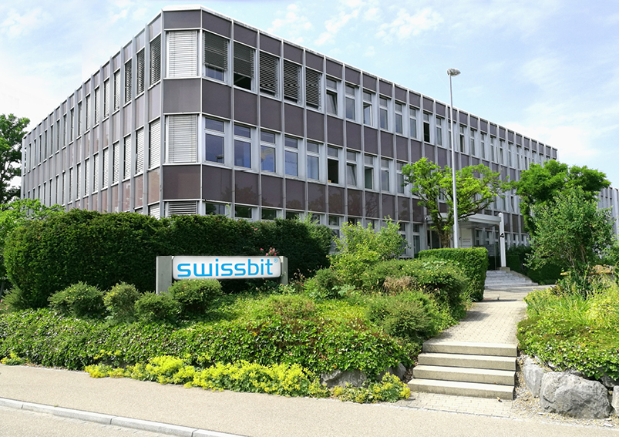
Image Source: Swissbit
Swissbit Headquarters: Bronschhofen (Switzerland)

About Swissbit AG
Swissbit is the largest independent manufacturer of embedded memory and flash storage solutions in Europe. The company was founded in 2001 through a management buy-out of Siemens AG, and has offices in Switzerland, Germany, US, Japan and Taiwan. Its main manufacturing plant in Berlin produces industrial strength flash memory products and memory cards with dedicated features for demanding applications. The Swissbit flash range includes SSDs with SATA interface as mSATA, Slim SATA, CFast™, M.2 and 2.5”, CompactFlash, USB flash drives, SD and micro SD memory cards. Swissbit offers products with long-term availability, high reliability and durability and custom optimization for demanding applications in the industrial, automotive and NetCom sectors.
With its secure storage solutions, Swissbit addresses the increasing security requirements demanded by industrial, government, defense, medical, NetCom, machine-to-machine communication and finance industry segments. All Swissbit products meet the highest quality standards and the RoHS and REACH directives.
For further information, please visit www.swissbit.com

Contact:  Swissbit AG  Silke Lüers  Industriestrasse 4  9552 Bronschhofen  Switzerland  Tel: +41 71 913 03 39  Email: silke.lueers@swissbit.com  www.swissbit.com | Press Agency:  HighTech communications GmbH  Brigitte Basilio  Brunhamstrasse 21  81249 Munich  Germany  Tel: +49 89 500778-20  Fax: +49 89 500778-77  Email: b.basilio@htcm.de  www.htcm.de

