PRESS RELEASE

Swissbit introduces industrial grade 3D-NAND-SSD
SATA-6-Gb/s-SSD for demanding industrial- & NetCom applications
Bronschhofen, Switzerland. July 16, 2019 – 3D-NAND-based SSD’s are common in consumer markets. Swissbit is now pleased to introduce a range of 3D-NAND-SSD products that are specifically optimized for demanding industrial- and NetCom applications. The X-75-range includes product versions with 2.5” housing, as well as m.2-, SlimSATA- and mSATA-modules.
Storage solutions specialist Swissbit has specifically fine-tuned its firmware to meet the requirements of industrial and NetCom companies. The firmware architecture, new features as well as the extensive product qualification and 100% final testing with long-term availability make X-75 an ideal SSD for applications such as automation, medical technology, industrial PCs, data-logging and NetCom-system boot-mediums.
Industrial 3D-NAND
This new family of industrial SATA-6-Gb/s-SSDs uses Toshiba BiCS3 NAND, specified and pretested to operate between -40 and 85°C, and Flash-controllers that support an impressive 165-bit-LDPC error correction. The 2.5” device has a tough die cast metal housing, which improves thermal behavior and stable performance. The robust and highly reliable products therefore conform to the demanding industrial temperature range of -40 to 85°C.
The 2.5” SSDs from the X-75 family will be available from 60GB to 2TB and are specified for both commercial and industrial temperature grades. Customers benefit from the longevity and attractive price points offered by the X-75 solutions while retaining the broad feature set of Swissbit’s popular X-60 range.
Designed for Endurance
The SSD range offers capacities from 240GB to 2TB and uses a direct TLC write mode without SLC cache, which reduces Write Amplification Factor (WAF) and maintains a high sustained write data rate. The firmware achieves maximum endurance out of the 3000 P/E cycles specified for the 3D-NAND components. The use of SLC-Cache for the 60 and 120 GB X-75-drives further improves top performance.
Swissbit’s Data Care Management with background scan, Near Miss ECC, and complete protection of internal data paths (E2E DPP - End-to-End Data Path Protection) offers additional safety against data loss. The firmware applies an efficient Block RAID for all drives, which allows recovery of full page fails.
3D-NAND-SSD with optional security features
As an option, the drives support AES256 encryption and TCG-OPAL-2.0 access protection. Furthermore, Swissbit’s Lifetime Monitor shows highly detailed information about the current lifetime status of the device.
“As a specialist for storage and security solutions for demanding industrial, IoT, IIoT and NetCom applications we continue to add security features to our latest 3D NAND SSD product, thus offering a highly reliable and easy-to-integrate product for industrial-strength applications”, says Grady Lambert, General Manager Swissbit NA Inc.

Available images
The following images are available for download in printable format at: http://www.htcm.de/kk/swissbit
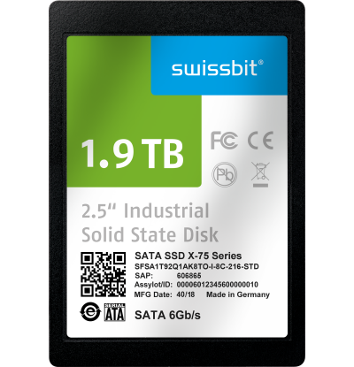
Image Source: Swissbit
3D-NAND-SATA 6Gb/s SSD X-75 from Swissbit for demanding applications

About Swissbit
Swissbit AG is the largest independent manufacturer of storage and security solutions for demanding industrial and IoT applications in Europe. Swissbit combines its unique competences in embedded memory and flash storage products with cutting-edge security technology and its expertise in advanced packaging to store, protect and process data reliably in industrial, NetCom, automotive, medical and finance sectors. The company manufactures industrial strength flash storage and security products “Made in Germany” with long-term availability, high reliability and durability as well as custom optimization. Swissbit’s flash range includes SSDs with PCIe and SATA interface such as mSATA, Slim SATA, CFast™, M.2 and 2.5” as well as CompactFlash, USB flash drives, SD, micro SD memory cards and managed NAND BGAs. Security products are available in various application specific editions as USB flash drives, SD, and micro SD memory cards. Swissbit was founded in 2001 through a management buy-out of Siemens AG, and has offices in Switzerland, Germany, USA, Japan and Taiwan.
For further information, please visit www.swissbit.com

Contact:  Swissbit AG  Zeljko Angelkoski  Industriestrasse 4  9552 Bronschhofen  Switzerland  Tel: +49 172 6325706  Email: zeljko.angelkoski@swissbit.com  www.swissbit.com | Press Agency:  HighTech communications GmbH  Brigitte Basilio  Brunhamstrasse 21  81249 Munich  Germany  Tel: +49 89 500778-20  Fax: +49 89 500778-77  Email: b.basilio@htcm.de  www.htcm.de

