PRESS RELEASE

Pluggable: Swissbit’s certified and secure microSD card for fiscal compliance
Easy-to-install Swissbit solution makes cash registers in Slovakia tamper-proof
Bronschhofen, Switzerland. October 2, 2019 – Swissbit collaborates with cash register solution suppliers, such as A3 Soft, AXASOFT, PC3000, Papaya POS and Solitea Pay in Slovakia to offer certified solutions for tamper-proof recording of POS (Point of sale) data . The Swissbit secure microSD card has recently been certified in Slovakia and allows easy system integration for both manufactures of traditional POS systems as well as POS software providers for PCs or tablets. For existing POS systems it is also a very cost-effective retrofit-solution.
It’s not an easy feat, but with the Swissbit fiscal product, manufacturers of cash registers now have a solution that can simply be plugged into any POS system via microSD-port, making it very easy to integrate and retrofit.
Future-proof and easy to integrate Swissbit fiscal solution
Cash register manufacturers can easily integrate the Swissbit fiscal solution into their systems. In addition to the secure microsSD card, Swissbit also provides an SDK (Software Development Kit), drivers and support for Windows, Linux, Android and embedded systems. In addition, the solution is future-proof and cost-effective.
"We fully understand the complex challenges faced by cash register manufacturers to provide legally compliant cash register. The Swissbit fiscal product is 'pluggable' and therefore offers a unique flexible and easy-to-integrate fiscal solution. Development and production are done in-house and can be completely controlled and flexibly adapted to our customers' requirements," said Hubertus Grobbel, Vice President Security Solutions at Swissbit AG.
Field-tested fiscal solution already used throughout the European Union
Swissbit is an established specialist with over 20 years’ experience in demanding industrial-grade storage and security solutions. In addition, Swissbit is well known for its high quality and security standards. The company maintains its own development and manufacturing site for memory products in Berlin, Germany and is therefore also able to offer a flexible and demand-oriented service for customized products. For over three years, Swissbit has been providing proven fiscal solutions in fiscal countries such as France and Germany.

Available images
The following images are available for download in printable format at: http://www.htcm.de/kk/swissbit
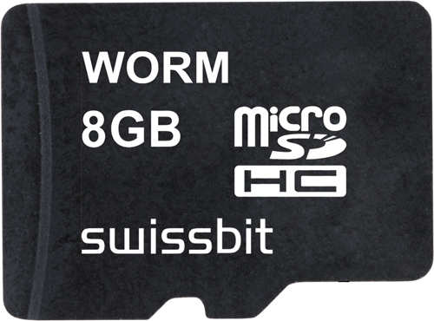
Image Source: Swissbit
Swissbit’s secure microSD card for the fiscal market in Slovakia is pluggable and easy to integrate. Existing POS systems can be easily retrofitted.

About Swissbit
Swissbit AG is the only independent manufacturer of storage and security solutions for demanding applications in the Internet of Things (IoT) in Europe. Swissbit combines its unique competences in storage products, cutting-edge security solutions with its expertise in advanced packaging to store and protect data reliably in industrial, NetCom, automotive, medical and finance applications. The company develops and manufactures industrial-grade storage and security products “Made in Germany” with long-term availability, high reliability and custom optimization. Swissbit’s storage range includes SSDs with PCIe and SATA interface such as mSATA, Slim SATA, CFast™, M.2 and 2.5” as well as CompactFlash, USB flash drives, SD, micro SD memory cards and managed NAND BGAs. Security products are available in various application specific editions as USB flash drives, SD, and micro SD memory cards. Swissbit was founded in 2001 through a management buy-out of Siemens AG, and has offices in Switzerland, Germany, USA, Japan and Taiwan.
For further information, please visit www.swissbit.com

Contact:  Swissbit AG  Zeljko Angelkoski  Industriestrasse 4  9552 Bronschhofen  Switzerland  Tel: +49 172 6325706  Email: zeljko.angelkoski@swissbit.com  www.swissbit.com | Press Agency:  HighTech communications GmbH  Brigitte Basilio  Brunhamstrasse 21  81249 Munich  Germany  Tel: +49 89 500778-20  Fax: +49 89 500778-77  Email: b.basilio@htcm.de  www.htcm.de

