PRESS RELEASE

Memory specialist triples production capacity for highly integrated system-in-package
Swissbit opens state-of-the-art electronics production facility in Berlin
Bronschhofen (Switzerland), Berlin, 5 December 2019 – Swissbit AG, a specialist provider of data-storage and security solutions for industrial applications and the Internet of Things (IoT), is pleased to announce the official opening of its new state-of-the-art electronics production facility in Berlin, Germany. Swissbit has been manufacturing in Germany since 2002. Now, the company has further strengthened its long-term commitment to Berlin as a manufacturing base and has tripled its production capacity for highly integrated electronics. New technology trends, such as growing digitalization and increased networking of devices in the Internet of Things, are driving the demand for memory and embedded IoT solutions. Secretary of State, Dr. Frank Nägele, took part in the reception at the high-tech factory in the CleanTech Business Park in Berlin-Marzahn. Swissbit is set to increase the number of jobs in development and production from 200 to up to 300 by 2023.
Taking just over a year to construct, the factory has been in operation since October 2019 with complex precision manufacturing of the latest memory and security modules for industrial use. The plant boasts almost 2,600m² of dedicated production floorspace. Swissbit is ideally positioned for growth markets, supplying the latest generation flash memory solutions and innovative security products for embedded IoT applications, including memory modules with integrated chips for authentication and data encryption. Digitalization will increase the demand for industrial memory products for industrial, Netcom, automotive (for example autonomous driving) and medical applications. Furthermore, increased networking of devices in the Internet of Things is seeing a dramatic rise in the requirements for the protection of data and devices and thus the demand for smart security products for embedded IoT solutions. Counterfeit protection for cash registers, which will be mandatory in Germany from 2020, is one of the application areas of the new Swissbit solution.
At the opening event, a tour of the facility offered guests an insight into the latest manufacturing technology and processes. In future, Swissbit will also offer access to its technology and processes to other developers of high-tech products as a service. This includes highly automated production equipment for assembly and connection technology for highly integrated electronics products, with placement capacities of, for example, 80,000 components per hour (cph). With continuous 300mm wafer handling and advanced 3D packaging capabilities, Swissbit delivers future-proof technologies that only a few companies globally have mastered in this form. In total, Swissbit invested 20 million EUR into the expansion and construction of the new production facility.
Commitment to Berlin as a location
“At our new manufacturing site in Berlin, we are able to showcase our state-of-the-art advanced packaging technologies and demonstrate the precision we achieve for the production of our highly integrated packages and memory modules. Normally, to experience similar facilities in action you would need to fly to Asia”, commented Silvio Muschter, CEO of Swissbit AG. “Swissbit products have always been and will remain ‘Made in Germany’. Our plant in Berlin has it all: skilled developers, proven experience and the latest equipment. We’re excited to be close to an important developer and start-up scene and thrive on the cooperation opportunities with local research and educational institutions that the location offers. We have already been actively fostering our involvement in these communities since 2002 and want to continue expanding – and that includes the creation of new high-tech jobs here in Berlin.”

Available images
The following images are available for download in printable format at: http://www.htcm.de/kk/swissbit
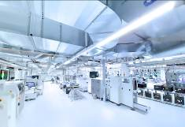 Image Source: Swissbit  At the opening ceremony of Swissbit’s high-tech factory on 4 December, guests enjoyed a tour to view the facility’s state-of-the-art production technologies. | 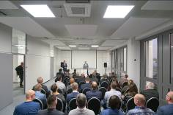  Image Source: Swissbit  Lars Lust, Berlin Site Manager at Swissbit, welcomed guests for the opening of the new facility.

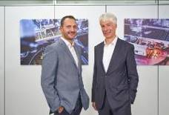 Image Source: Swissbit  Lars Lust (left), Berlin Site Manager at Swissbit, and Secretary of State Dr. Ing. Frank Nägele who participated in the opening ceremony as a representative of the Berlin Senate Chancellery. | 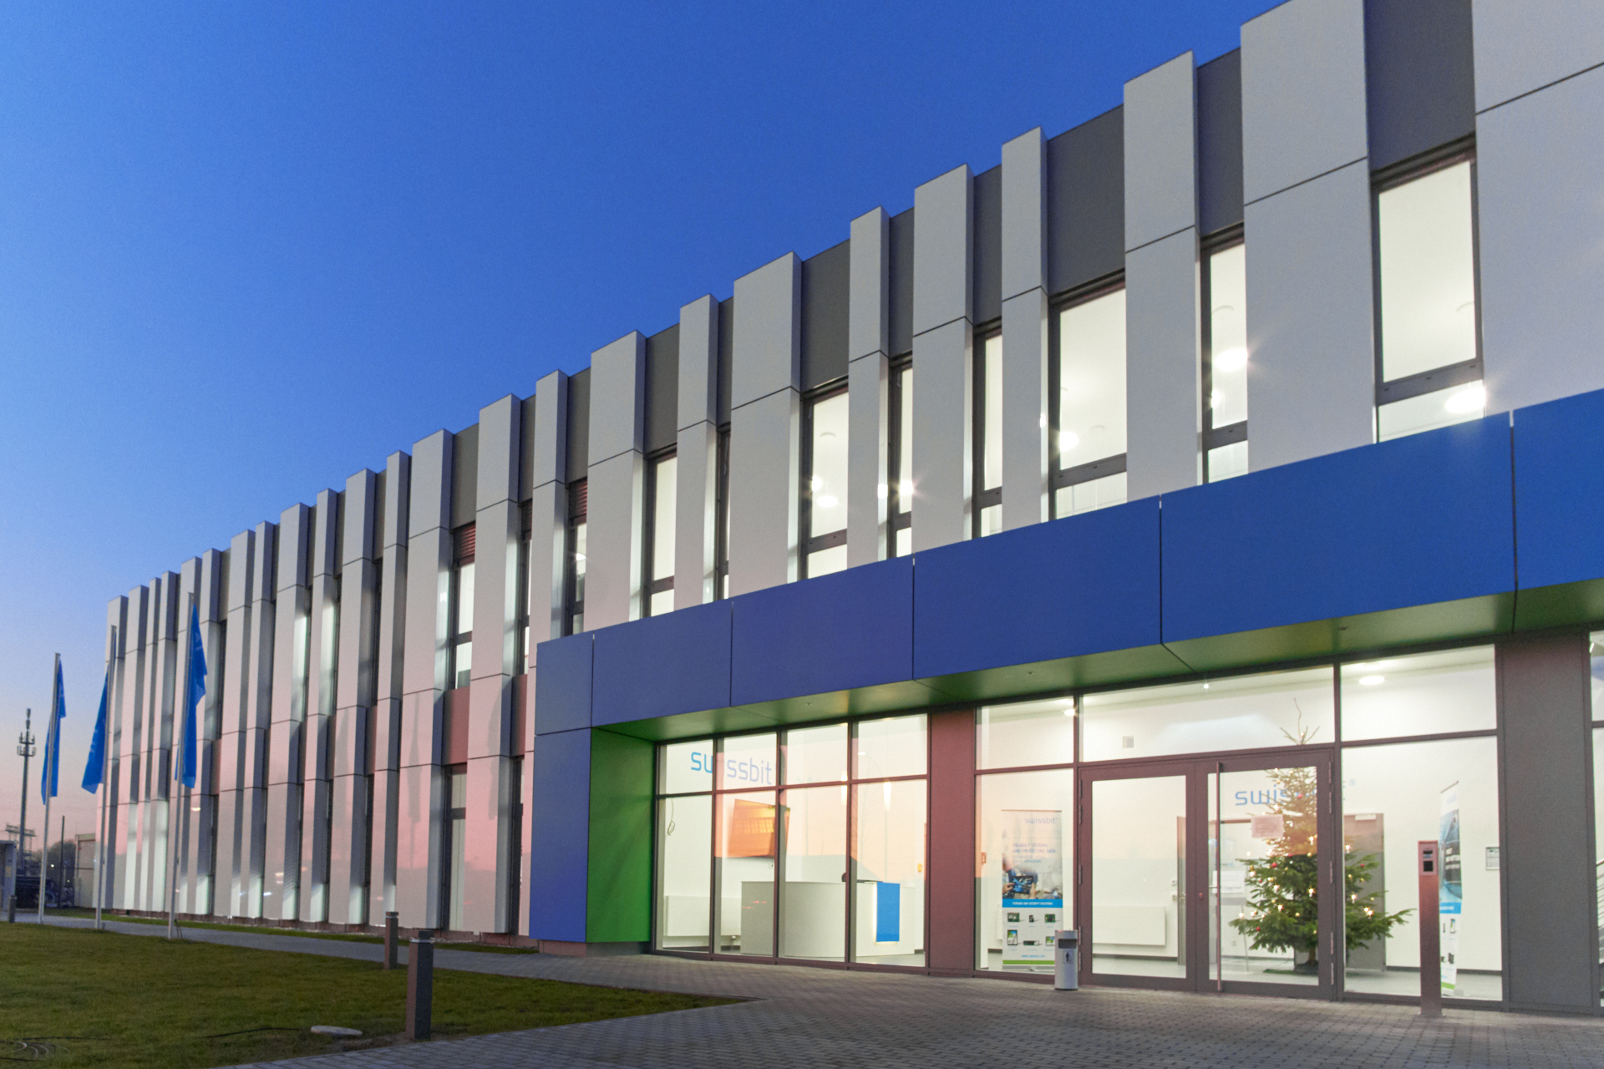Image Source: Swissbit  With just under 2,600 square meters of dedicated production space, the sophisticated precision manufacturing facility produces state-of-the-art, industrial-grade storage and security modules.

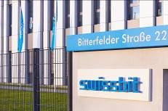
Image Source: Swissbit
Swissbit also offers access to its state-of-the-art production technologies and processes to developers of high-tech products.

About Swissbit
Swissbit AG is the only independent manufacturer of storage and security solutions for demanding applications in the Internet of Things (IoT) in Europe. Swissbit combines its unique competences in storage and security products with its expertise in advanced packaging to store and protect data reliably in industrial, NetCom, automotive, medical and finance applications. The company develops and manufactures industrial-grade storage and security products “Made in Germany” with long-term availability, high reliability and custom optimization.
Swissbit’s storage range includes SSDs with PCIe and SATA interface such as mSATA, Slim SATA, CFast™, M.2 and 2.5” as well as CompactFlash, USB flash drives, SD, micro SD memory cards and managed NAND BGAs. Security products are available in various application specific editions as USB flash drives, SD, and micro SD memory cards. Swissbit was founded in 2001 through a management buy-out of Siemens AG, and has offices in Switzerland, Germany, USA, Japan and Taiwan.
For further information, please visit www.swissbit.com

Contact:  Swissbit AG  Zeljko Angelkoski  Industriestrasse 4  9552 Bronschhofen  Switzerland  Tel: +49 172 6325706  Email: zeljko.angelkoski@swissbit.com  www.swissbit.com | Press Agency:  HighTech communications GmbH  Brigitte Basilio  Brunhamstrasse 21  81249 Munich  Germany  Tel: +49 89 500778-20  Fax: +49 89 500778-77  Email: b.basilio@htcm.de  www.htcm.de

