
PRESS RELEASE
Online Event,
9–12 November 2020
Swissbit showcases industrial-quality memory and security products at electronica virtual.
Store and protect data reliably.
Bronschhofen, Switzerland. November 5, 2020 – Swissbit AG will be presenting robust and durable flash memory solutions for industrial applications at electronica virtual 2020, the digital platform of the biennial electronica show from November 9 to 12, 2020. Swissbit’s Embedded IoT Solutions division, which was founded one year ago, will showcase its hardware-based security solutions designed to protect data and devices in Internet of Things (IoT) applications. The compelling Embedded IoT growth market and its challenges are also the subject of a Swissbit presentation in the conference program at the exhibition.
At 12:10pm on November 12, 2020, the topic “IoT security embedded in memory cards” will be on the agenda at the Embedded Platforms Conference (Track 4). The speaker is Christian Ullrich, Senior Product Manager Embedded IoT Solutions at Swissbit AG.
Reliable memory products of industrial quality.
Swissbit's product showcase on Flash Memory for Industrial Applications goes by the headline: “Endurance with 3D-NAND”. Making flash technology, which is normally geared towards low-cost mass storage for consumers, usable as durable, robust media in industrial applications is Swissbit's signature achievement.
The S-50 and S-56 series are SD and microSD memory cards that tolerate fluctuating temperatures between read and write operations over the entire specified temperature range of -40 to +85°C. Due to these resilient characteristics, this series offers the highest reliability for demanding applications such as data recorders and industrial PCs.
With its N-20m2, Swissbit offers a robust and powerful SSD featuring low power consumption and quad PCIe-3.1 interface. It is available in standard 2242 and 2280 dimensions as well as the smaller M.2 2230 form factor. This memory module is the ideal boot medium for small embedded systems and routers.
Another product in compact BGA format is the new EM-30 in the e.MMC 5.1 standard. Capacities from 16 to 256 GB are available and, thanks to 3D-NAND, it is significantly more cost-effective than previous 2D-NAND products. Applications range from embedded systems, POS/POI terminals, factory automation, routers and switches to Internet of Things (IoT) and medical systems solutions.
Secure security products “Made in Germany”.
In its state-of-the-art factory in Berlin (Germany), Swissbit proudly manufactures security products as highly integrated systems-in-package under the “Made in Germany” banner. One of the products demonstrates how intelligent security functions can be integrated into storage media: the Swissbit Technical Security Device (TSE) for the conversion of POS systems. Swissbit was the first manufacturer to offer a certified TSE that makes POS systems tamper-proof – as a stand-alone device, LAN connected or a cloud solution.
By using familiar form factors and common flash storage media interfaces, Swissbit provides manufacturers of embedded IoT systems with a convenient, low-cost and low-effort integration approach. By means of a secure element and cryptographic functions, the security modules assume the function of a TPM (Trusted Platform Module) and undertake encryption tasks. This enables the secure authentication of M2M communication participants and data encryption in networked devices, machines and systems.
To make it simpler for developers to adopt data protection measures using storage-based security solutions, Swissbit offers a Secure Boot solution for Raspberry Pi.

Available images
The following images are available for download in printable format at: http://www.htcm.de/kk/swissbit
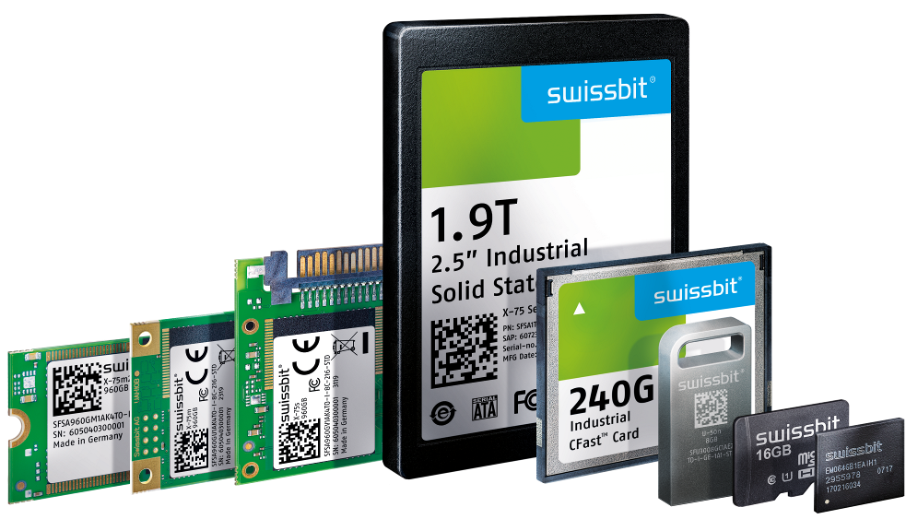  Image Source: Swissbit  Swissbit presents reliable and industrial-compatible storage and security products at electronica virtual 2020. | 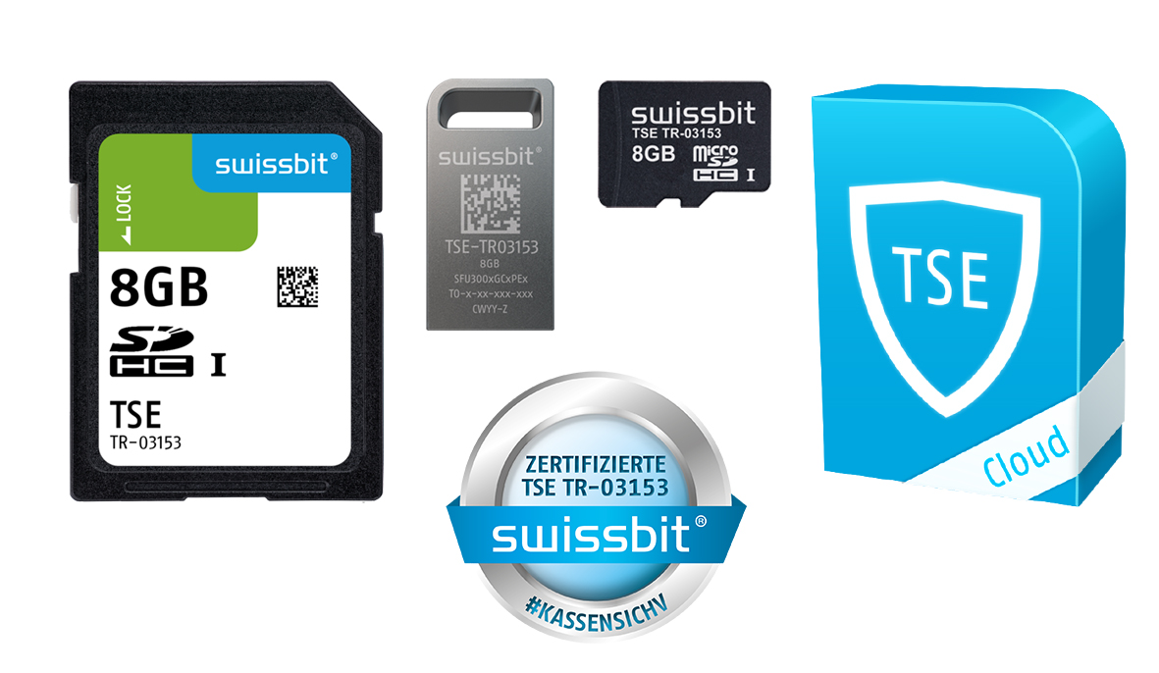  Image Source: Swissbit  Technical Security Devices (TSE) for tamper-proof recording of cash register data.

  Image Source: Swissbit  Swissbit presents hardware-based security solutions for the protection of data and devices at electronica virtual. |   Image Source: Swissbit  The new factory in Berlin offers everything for complex precision manufacturing of state-of-the-art, industrial-strength storage and security modules.

About Swissbit
Swissbit AG is the only independent European manufacturer of storage and embedded IoT solutions for demanding applications. Swissbit combines its unique competences in storage and embedded IoT technology with its advanced packaging knowhow. This expertise allows our customers to reliably store and protect data in critical industrial, NetCom, automotive, medical and finance applications as well as across the Internet of Things (IoT).
Swissbit develops and manufactures industrial-grade storage and security products “Made in Germany” with high reliability, long-term availability, and custom optimization.
Swissbit’s storage range includes SSDs with PCIe and SATA interface such as mSATA, Slim SATA, CFast™, M.2 and 2.5” as well as CompactFlash, USB flash drives, SD Memory Cards, micro SD Memory Cards and managed NAND BGAs like e.MMC. Security products are available in various application specific editions as USB flash drives, SD Memory Cards, and micro SD Memory Cards.
Swissbit was founded in 2001 and has offices in Switzerland, Germany, USA, Japan and Taiwan.
For further information, please visit www.swissbit.com

Regional Headquarters:
Swissbit Germany AG
Bitterfelder Strasse 22
12681 Berlin
Germany
Tel: +49 30 936 954 0
Email: info@swissbit.com
www.swissbit.com
Headquarters:
Swissbit AG
Industriestrasse 4
9552 Bronschhofen
Switzerland
Tel: +41 71 913 03 03
Email: info@swissbit.com
www.swissbit.com
Contact:  Swissbit AG  Zeljko Angelkoski  Industriestrasse 4  9552 Bronschhofen  Switzerland  Tel: +49 172 6325706  Email: zeljko.angelkoski@swissbit.com  www.swissbit.com | Press Agency:  HighTech communications GmbH  Brigitte Basilio  Brunhamstrasse 21  81249 Munich  Germany  Tel: +49 89 500778-20  Fax: +49 89 500778-77  Email: b.basilio@htcm.de  www.htcm.de

