PRESS RELEASE
Swissbit-TSE renders Vectron cash registers tamper-proof
Successful roll-out to fully comply with German Cash Security Ordinance (KassenSichV)
Berlin, Münster, Germany. 15 September 2020 – Vectron Systems AG (Vectron), one of the largest European manufacturers of POS systems, began equipping cash registers with technical security devices (TSE) back in December 2019. To date, Vectron has supplied more than 18,000 BSI-certified TSE solutions from Swissbit through its specialist trade partner network to users predominantly in the hospitality and bakery industries, enabling tamper-proof recording of cash register data in accordance with the German Cash Security Ordinance (KassenSichV). Time is of the essence: by 30 September, 2020 the commissioning of a legally compliant conversion of POS systems must be ensured and its technical implementation completed by 31 March, 2021. Cash register operators who have yet to convert their device or those in need of new cash registers should their existing ones not be convertible, can contact a Vectron trade partner to acquire a legally compliant cash register equipped with a TSE. Swissbit offers TSE products in the form of USB sticks, SD and microSD cards.
"Our decision in favor of the fiscalization solution from Swissbit AG was made early on and we made all necessary software adaptations accordingly. In contrast to announced cloud solutions, Swissbit TSE products have been certified since the end of 2019 and are tried and tested. They are easy to use and reliable because they also work offline", says Markus Koch, Head of Procurement at Vectron Systems AG. "Our advice to all users of POS systems without a TSE is to contact a cash register specialist as soon as possible to avoid high fines that may be imposed in case of non-compliance".
TSE solutions by Swissbit ensure legally complaint conversion of POS systems
"Our flexible, pluggable TSE solutions enable cash register manufacturers and system service providers to implement the requirements and meet the legal deadlines with ease", explains Hubertus Grobbel, Vice President Security Solutions at Swissbit.
Swissbit was the first manufacturer to receive TSE certification for storage solutions in Germany. With USB sticks, SD and microSD cards from Swissbit, almost every modern POS system can be retrofitted to meet the requirements of the German Cash Security Ordinance. An optional LAN solution enables the efficient retrofitting of networked POS systems. In this way, devices in different locations can be easily retrofitted to be legally compliant without any further hardware intervention at the individual cash registers. In addition to the secure fiscal memory where the automatically signed transactions are stored, the Swissbit TSE memory solutions offer a user memory that can be freely used by POS equipment manufacturers.

Available images
The following images are available for download in printable format at: http://www.htcm.de/kk/swissbit
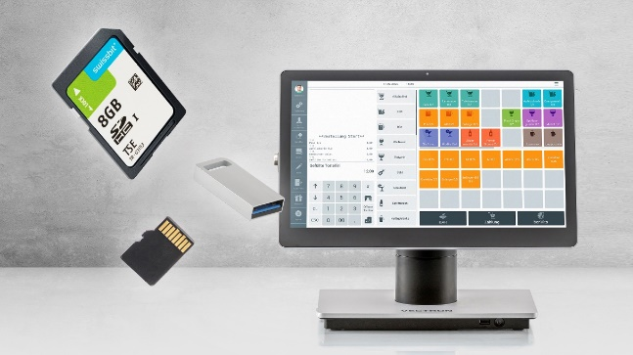Image Source: Vectron Systems AG
Vectron offers legally compliant cash registers with TSE (Technical Security Device).

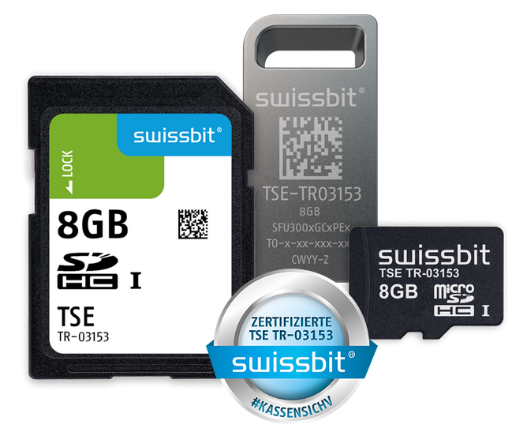Image Source: Swissbit
Swissbit was the first manufacturer to receive TSE certification for storage solutions. With these, almost every modern POS system can be retrofitted to be legally compliant without any further hardware intervention

About Vectron
With over 225,000 installations, the listed Vectron Systems AG is one of the leading European manufacturers of POS systems. Stable hardware combined with flexible, reliable software has made Vectron a market leader within the hospitality and bakery industries in German-speaking countries and in Benelux. Several hundred specialist trade partners distribute the products internationally. Digital Cloud Services are offered under the brand names myVectron and bonVito. The spectrum ranges from loyalty and payment functions to online reservations and online reporting. All the services are directly connected to the POS system, making it the core data center. More information available at www.vectron.de.

About Swissbit
Swissbit AG is the only independent European manufacturer of storage and embedded IoT solutions for demanding applications. Swissbit combines its unique competences in storage and embedded IoT technology with its advanced packaging knowhow. This expertise allows our customers to reliably store and protect data in industrial, NetCom, automotive, medical and finance applications as well as across the Internet of Things (IoT).
Swissbit develops and manufactures industrial-grade storage and security products “Made in Germany” with long-term availability, high reliability and custom optimization.
Swissbit’s storage range includes SSDs with PCIe and SATA interface such as mSATA, Slim SATA, CFast™, M.2 and 2.5” as well as CompactFlash, USB flash drives, SD, micro SD memory cards and managed NAND BGAs. Security products for embedded IoT applications are available in various application specific editions as USB flash drives, SD, and micro SD memory cards.
Swissbit was founded in 2001 and has offices in Switzerland, Germany, USA, Japan and Taiwan.
For further information, please visit www.swissbit.com

Regional Headquarters:
Swissbit Germany AG
Bitterfelder Strasse 22
12681 Berlin
Germany
Tel: +49 30 936 954 0
Email: info@swissbit.com
www.swissbit.com

Headquarters:
Swissbit AG
Industriestrasse 4
9552 Bronschhofen
Switzerland
Tel: +41 71 913 03 03
Email: info@swissbit.com
www.swissbit.com
Contact:  Swissbit AG  Zeljko Angelkoski  Industriestrasse 4  9552 Bronschhofen  Switzerland  Tel: +49 172 6325706  Email: zeljko.angelkoski@swissbit.com  www.swissbit.com | Press Agency:  HighTech communications GmbH  Brigitte Basilio  Brunhamstrasse 21  81249 Munich  Germany  Tel: +49 89 500778-20  Fax: +49 89 500778-77  Email: b.basilio@htcm.de  www.htcm.de

