PRESS RELEASE
Swissbit extends its certified TSE solutions with a Cloud TSE
Swissbit's portfolio of single device, LAN and cloud solutions provides full flexibility for all applications
Berlin, Germany. October 26, 2020 – Swissbit is expanding its certified and established range of TSE (Technical Security Device) products, with the addition of the certified Swissbit Cloud TSE for online or cloud POS systems. Swissbit TSE solutions are already available for single devices and networked POS systems. This new addition makes Swissbit a complete provider of tamper-proof recording solutions for POS data in accordance with the German Cash Security Ordinance (KassenSichV), offering maximum flexibility for all applications and easy switching between technologies. Swissbit solutions enable all companies to implement a legally compliant conversion of their POS systems by March 31, 2021.
"Whether single devices, networked POS systems in a LAN or online-capable POS systems with a cloud connection, we provide an easy-to-integrate, flexible and secure TSE connection for all scenarios", explains Hubertus Grobbel, Vice President Security Solutions at Swissbit.
POS manufacturers receive convenient and standardized interfaces for local and cloud-based POS systems, which allows them to easily switch between the technologies as needed. “We also offer businesses an interface to the DATEV fiscalization platform, which amongst other great benefits, offers an intuitive POS-data archiving and checking feature and provides businesses with access to an ideal fiscal services package," Grobbel continues.
The Swissbit Cloud TSE: simple, flexible and secure.
The Swissbit Cloud TSE is particularly suitable for companies wishing to connect their POS systems to the cloud now or in the future. With the use of cloud cash registers supported for the first time, companies with a centralized infrastructure and numerous cash registers or branches, such as large retail chains, supermarkets, pharmacies and businesses in the catering & hospitality sector, can also benefit significantly from this cloud-connected proposition.
The certified Swissbit Cloud TSE uses in addition to the “Swissbit Cloud TSE Connector”, including the local SMAERS component (Security Module Application for Electronic Record-keeping Systems), also a central web service with a signature service including key management, certified as a Cryptographic Service Provider (CSP), on which configuration and monitoring is carried out. The local component does not require any hardware and runs either directly on the cash register or from the branch back-office. The local component also handles secure communication with the web service in the cloud.
Certified Swissbit TSE for single devices and networked POS systems in LAN.
Swissbit was the first manufacturer to receive TSE certification for storage solutions in Germany. With USB sticks, SD and microSD cards from Swissbit, almost every modern POS system can be retrofitted to meet the requirements of the German Cash Security Ordinance. An optional LAN solution enables the efficient retrofitting of networked POS systems. In this way, devices in different locations, such as PC cash registers or tablets, can be easily retrofitted to be legally compliant without any further hardware intervention at the individual cash registers. In addition to the secure fiscal memory where the automatically signed transactions are stored, the Swissbit TSE memory solutions offer a user memory that can be freely used by POS equipment manufacturers.
The core of the certified Swissbit TSE is a durable, industrial flash memory with signature certificate in accordance with TR-03145 and the Common Criteria (CC) certified security modules BSI-PP-SMAERS and BSI-PP-CSP.

Available images
The following images are available for download in printable format at: http://www.htcm.de/kk/swissbit
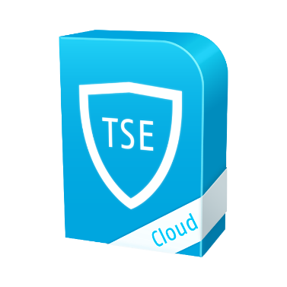  Image Source: Swissbit  Swissbit Cloud TSE | 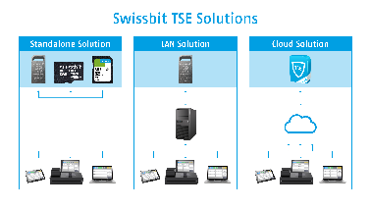  Image Source: Swissbit  Swissbit TSE solutions provide full flexibility for all applications

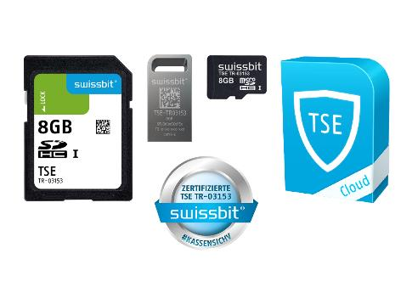
Image Source: Swissbit
Certified Swissbit TSE products provides full flexibility.

About Swissbit
Swissbit AG is the only independent European manufacturer of storage and embedded IoT solutions for demanding applications. Swissbit combines its unique competences in storage and embedded IoT technology with its advanced packaging knowhow. This expertise allows our customers to reliably store and protect data in critical industrial, NetCom, automotive, medical and finance applications as well as across the Internet of Things (IoT).
Swissbit develops and manufactures industrial-grade storage and security products “Made in Germany” with high reliability, long-term availability, and custom optimization.
Swissbit’s storage range includes SSDs with PCIe and SATA interface such as mSATA, Slim SATA, CFast™, M.2 and 2.5” as well as CompactFlash, USB flash drives, SD Memory Cards, micro SD Memory Cards and managed NAND BGAs like e.MMC. Security products are available in various application specific editions as USB flash drives, SD Memory Cards, and micro SD Memory Cards.
Swissbit was founded in 2001 and has offices in Switzerland, Germany, USA, Japan and Taiwan.
For further information, please visit www.swissbit.com

Regional Headquarters:
Swissbit Germany AG
Bitterfelder Strasse 22
12681 Berlin
Germany
Tel: +49 30 936 954 0
Email: info@swissbit.com
www.swissbit.com
Headquarters:
Swissbit AG
Industriestrasse 4
9552 Bronschhofen
Switzerland
Tel: +41 71 913 03 03
Email: info@swissbit.com
www.swissbit.com
Contact:  Swissbit AG  Zeljko Angelkoski  Industriestrasse 4  9552 Bronschhofen  Switzerland  Tel: +49 172 6325706  Email: zeljko.angelkoski@swissbit.com  www.swissbit.com | Press Agency:  HighTech communications GmbH  Brigitte Basilio  Brunhamstrasse 21  81249 Munich  Germany  Tel: +49 89 500778-20  Fax: +49 89 500778-77  Email: b.basilio@htcm.de  www.htcm.de

