PRESS RELEASE
Swissbit and DATEV make fiscalization easy
Certified TSE solutions from Swissbit with direct connection to ‘MeinFiskal’ platform from DATEV
Berlin, Germany. November 3, 2020 – Swissbit, a leading provider of certified TSE (Technical Security Device) solutions, has partnered with IT service provider DATEV to offer its customers the perfect solution for tamper-proof recording and archiving of POS (Point of Sale) data. The certified (BSI TR-03153) single device and networked POS system TSE’s, as well as the recently certified Cloud TSE for online or cloud POS systems are now available with an easy connection to DATEV's cloud platform ‘MeinFiskal’. As a full-service provider of easy-to-integrate and secure TSE solutions, Swissbit enables POS manufacturers and system integrators maximum flexibility for all use cases.
For all types of applications, Swissbit offers easy-to-integrate, flexible and secure TSE solutions for single devices, networked POS systems in LAN configurations and online-capable POS systems with a cloud connection. POS manufacturers have access to convenient and standardized interfaces for Windows, Linux and Android with a pre-integrated connection to the cloud platform ‘MeinFiskal’ from DATEV.
"Swissbit is the first TSE solutions provider to offer all POS manufacturers a connection to the 'MeinFiskal' cloud platform from DATEV - a reliable and simple solution for POS data archiving and verification. It’s the ideal fiscal package for businesses", explains Hubertus Grobbel, Vice President Security Solutions at Swissbit.
‘MeinFiskal’ facilitates tax-compliant cash management
‘MeinFiskal’ has been developed as an open ecosystem for legally compliant cash management solutions. The core of the new platform is the already established solution "DATEV Kassenarchiv online", which ensures legally compliant and tamper-proof archiving of fiscal data from cash registers in the secure DATEV cloud. Among other things, intelligent check routines ensure that archived data is complete and has not been modified. "MeinFiskal" can offer cash register operators additional value-added services close to the cash register, such as compliance functions, data analyses, connection to follow-up processes or mandatory reporting of cash registers and technical security devices (TSE) to the tax authorities.
"DATEV’s 'MeinFiskal' cloud platform helps small and medium-sized businesses digitally process cash register data and meet all legal requirements for electronic cash registers. Swissbit has been involved in the platform from the very beginning," says Stefan Hummel, Product-Owner Accounting Vorsysteme, DATEV eG.
Certified TSE solutions from Swissbit: simple, flexible and secure
Swissbit was the first manufacturer to receive TSE certification for storage solutions in Germany. With USB sticks, SD memory cards and microSD memory cards from Swissbit, almost every modern POS system can be retrofitted to meet the requirements of the German Cash Security Ordinance.
Networked POS systems can be efficiently retrofitted with a LAN solution. With this, different devices across entire locations, such as PC cash registers or tablets, can be retrofitted in compliance with the law without the need for hardware modifications of individual cash registers. In addition to a secure fiscal memory, which stores the automatically signed transactions, the Swissbit TSE also makes a user memory freely available to cash register manufacturers.
The new Swissbit Cloud TSE is particularly suitable for companies wishing to connect their POS systems to the cloud now or in the future without the need for hardware. For large retail chains with centrally controlled POS system infrastructures, for example, this cloud-connected solution can be especially beneficial. For the first time, cloud-based cash registers are now supported.
Swissbit is pleased to offer the great customer benefits provided by the integration of the DATEV fiscal service.

Available images
The following images are available for download in printable format at: http://www.htcm.de/kk/swissbit
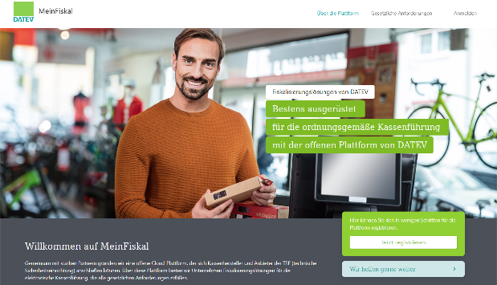  Image source: DATEV  ‘MeinFiskal’ facilitates tax-compliant cash management | 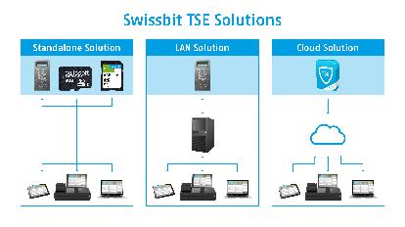  Image source: Swissbit  For all applications Swissbit TSE solutions offer full flexibility for all applications.

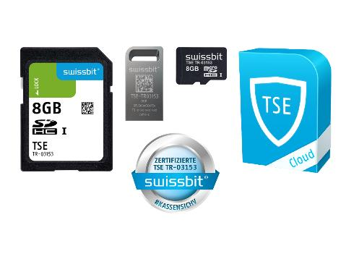
Image source: Swissbit
Certified Swissbit TSE Products offer full flexibility.

About Swissbit
Swissbit AG is the only independent European manufacturer of storage and embedded IoT solutions for demanding applications. Swissbit combines its unique competences in storage and embedded IoT technology with its advanced packaging knowhow. This expertise allows our customers to reliably store and protect data in critical industrial, NetCom, automotive, medical and finance applications as well as across the Internet of Things (IoT).
Swissbit develops and manufactures industrial-grade storage and security products “Made in Germany” with high reliability, long-term availability, and custom optimization.
Swissbit’s storage range includes SSDs with PCIe and SATA interface such as mSATA, Slim SATA, CFast™, M.2 and 2.5” as well as CompactFlash, USB flash drives, SD Memory Cards, micro SD Memory Cards and managed NAND BGAs like e.MMC. Security products are available in various application specific editions as USB flash drives, SD Memory Cards, and micro SD Memory Cards.
Swissbit was founded in 2001 and has offices in Switzerland, Germany, USA, Japan and Taiwan.
For further information, please visit www.swissbit.com

Regional Headquarters:
Swissbit Germany AG
Bitterfelder Strasse 22
12681 Berlin
Germany
Tel: +49 30 936 954 0
Email: info@swissbit.com
www.swissbit.com
Headquarters:
Swissbit AG
Industriestrasse 4
9552 Bronschhofen
Switzerland
Tel: +41 71 913 03 03
Email: info@swissbit.com
www.swissbit.com
Contact:  Swissbit AG  Zeljko Angelkoski  Industriestrasse 4  9552 Bronschhofen  Switzerland  Tel: +49 172 6325706  Email: zeljko.angelkoski@swissbit.com  www.swissbit.com | Press Agency:  HighTech communications GmbH  Brigitte Basilio  Brunhamstrasse 21  81249 Munich  Germany  Tel: +49 89 500778-20  Fax: +49 89 500778-77  Email: b.basilio@htcm.de  www.htcm.de

