PRESS RELEASE

Swissbit SSDs recommended for mobile video surveillance applications
Outstanding performance of X-75 2.5" SSDs in r2p benchmark
Bronschhofen, Switzerland. December 8, 2020 – r2p GmbH, a leading provider of intelligent technology solutions for public transportation, has subjected 2.5" media from nine SSD and two HDD manufacturers to rigorous testing for video storage in mobile surveillance solutions for buses and trains. The result of the benchmark that includes vibration and temperature stress tests according to IEC 61373:1999 Railway applications – Rolling stock equipment concluded that the Swissbit X-75 2.5" SATA SSDs in capacities of 60, 120, 240 and 480GB proved especially suitable for use in demanding mobile applications.
The data drives were cooled or heated in a series of tests to a range of temperatures between -40°C and +85°C, remaining at the set temperature for 30 minutes each. During these thermal stress periods, the units were operated to play a test video. The outcome of the tests showed that Swissbit X-75 2.5" SATA SSDs were ready for operation under all conditions and also exhibited consistently positive results in a subsequent evaluation.
Optimized SSD firmware delivers greater robustness and reliability
An ability to tolerate temperature differentials during write and read operations of up to 125 Kelvin is a key feature of industrial memory products. “I am delighted with the r2p benchmark results,” says Roger Griesemer, General Manager Memory Solutions at Swissbit. “Once again, we proved that we could ensure optimal performance with superior access methods and error correction in the firmware, even for memory products based on the more temperature-sensitive 3D-NAND memory technology,” he explains. “Electronic circuitry, process technology and component selection for these applications are equally crucial, and the development team demonstrated its knowledge and capabilities in these areas.” Rüdiger Nehring, Product Manager at r2p added: “The tests are very important for us and we are pleased to have found another manufacturer of reliable storage media and a business partner in Swissbit.”
The Swissbit SSDs proved equally robust when subjected to mechanical testing. Due to the mechanical structure of hard disks, the testers observed that current HDDs exhibit failures at lower forces than SSDs. “For us, this means that solid state drives are the first choice for harsh operating conditions and that our NAND flash memory products, which are specifically optimized for durability and reliability, continue to perform where standard SSDs fail,” says Griesemer.
The Swissbit X-75 series are SATA III SSDs. In addition to the 2.5" form factor used in the r2p benchmark, the SSDs are also available in M.2 2280 and M.2 2242 as well as mSATA MO-300 and SlimSATA MO-297, which are ideally suited to embedded systems.

Available images
The following images are available for download in printable format at: http://www.htcm.de/kk/swissbit
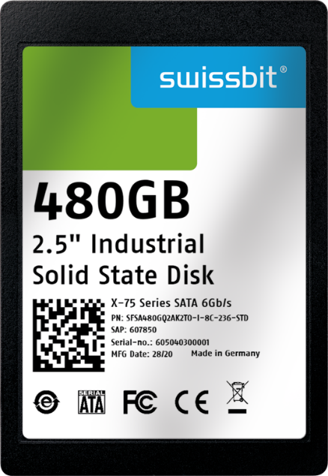 Image Source: Swissbit
3D-NAND SATA 6 Gb/s SSD X-75 from Swissbit for demanding industrial applications

About Swissbit
Swissbit AG is the only independent European manufacturer of storage and embedded IoT solutions for demanding applications. Swissbit combines its unique competences in storage and embedded IoT technology with its advanced packaging knowhow. This expertise allows our customers to reliably store and protect data in critical industrial, NetCom, automotive, medical and finance applications as well as across the Internet of Things (IoT).
Swissbit develops and manufactures industrial-grade storage and security products “Made in Germany” with high reliability, long-term availability, and custom optimization.
Swissbit’s storage range includes SSDs with PCIe and SATA interface such as mSATA, Slim SATA, CFast™, M.2 and 2.5” as well as CompactFlash, USB flash drives, SD Memory Cards, micro SD Memory Cards and managed NAND BGAs like e.MMC. Security products are available in various application specific editions as USB flash drives, SD Memory Cards, and micro SD Memory Cards.
Swissbit was founded in 2001 and has offices in Switzerland, Germany, USA, Japan and Taiwan.
For further information, please visit www.swissbit.com

Regional Headquarters:
Swissbit Germany AG
Bitterfelder Strasse 22
12681 Berlin
Germany
Tel: +49 30 936 954 0
Email: info@swissbit.com
www.swissbit.com
Headquarters:
Swissbit AG
Industriestrasse 4
9552 Bronschhofen
Switzerland
Tel: +41 71 913 03 03
Email: info@swissbit.com
www.swissbit.com
Contact:  Swissbit AG  Zeljko Angelkoski  Industriestrasse 4  9552 Bronschhofen  Switzerland  Tel: +49 172 6325706  Email: zeljko.angelkoski@swissbit.com  www.swissbit.com | Press Agency:  HighTech communications GmbH  Brigitte Basilio  Brunhamstrasse 21  81249 Munich  Germany  Tel: +49 89 500778-20  Fax: +49 89 500778-77  Email: b.basilio@htcm.de  www.htcm.de

