
PRESS RELEASE

embedded world DIGITAL: Highlights and innovations from Swissbit
Industry-optimized memory products for a wide range of applications & hardware-based security solutions for the IoT
Bronschhofen, Switzerland. February 4, 2021 – At embedded world 2021 DIGITAL, Swissbit will focus on its expanding memory solutions portfolio of highly reliable, industrial-grade product ranges. Highlights include the S-5x SD and microSD card family, the G-2x CFexpress 2.0 card series and the EM-3x BGA device in the e.MMC-5.1 standard. For embedded IoT applications, Swissbit will focus on its certified TSE solution, which is now also available as a cloud application. The array of product highlights will be rounded off with the Swissbit Secure Boot Solution for Raspberry Pi and the presentation of a completely new product family: the iShield Camera Series – a plug-&-play security solution for protecting camera data.
Swissbit AG, which acquired controller specialist Hyperstone at the turn of the year, sees embedded world DIGITAL as the ideal platform to strengthen its position as a leading supplier of durable memory products of industrial quality as well as forward-looking solutions for security and embedded IoT.
Memory solutions: a strong portfolio for all industrial requirements
With the S-5x memory card family, Swissbit addresses customers who are confronted with demanding applications. Based on industrial 3D NAND technology, the S-50 and S-56 series cards combine flash chips, a powerful controller and firmware in a robust housing to deliver maximum reliability. All models in the S-5x family comply with the SD-6.1 specification and support full SPI mode. This makes the S-5x portfolio particularly suitable for applications that include data recorders, industrial PCs, automation controllers, POS terminals, medical devices and surveillance cameras.
The CFexpress card series G-20 is characterized by very high reliability, performance and data protection features. The pluggable storage media, available in capacities of up to 480 Gb, target applications in the fields of industrial automation, transportation, and medical technology with a high-performance interface adhering to 2-lane NVMe 1.3 and PCIe Gen 3.1 specifications. This positions the G-20 series as a high-performance addition to industry-standard removable media.
Solderable, reliable and cost-efficient
Swissbit is expanding its range of miniaturized memory solutions with the EM-3x series. The BGA device in the e.MMC-5.1 form factor combines a modern controller with industrial-grade 3D NAND and optimized firmware that supports demanding applications. These features make the EM-3x particularly attractive for use in embedded IoT applications, in automotive environments or in factory automation.
Embedded IoT Solutions: unique security for data and devices
In the area of hardware-based security solutions, Swissbit focuses on its certified range of TSEs (Technical Security Equipment) for tamper-proof recording of POS data. In addition to its established solutions for individual devices and networked cash register systems (LAN), the Swissbit Cloud TSE completes the portfolio with a variant for online or cloud cash registers. This enables Swissbit to provide all businesses with timely and legally compliant solutions to convert cash register systems by March 31, 2021, while offering maximum flexibility for all use cases.
For the widely used Raspberry Pi hardware platform, Swissbit offers an easy-to-implement security solution. The Swissbit Secure Boot Solution consists of a PS-45u-DP microSD card “Raspberry Edition” and a software development kit. This enables the effective securing of the Raspberry Pi bootloader, thereby encrypting or write-protecting boot and application code, proprietary know-how and intellectual property.
Premiering at embedded world DIGITAL, Swissbit will be offering a first glimpse of a completely new product family. The iShield Camera series will enrich the portfolio in the field of security products in the future. The host-independent plug-&-play solution in the form of a microSD card enables encryption and access protection for recorded camera data. It is compatible with popular still image and video recording devices. Manufacturers specifically benefit from the plug-&-play approach that enables easy retrofitting of existing systems. Possible applications range from dashcams and drones to bodycams and wildlife cameras. Further details on the iShield Camera series will be announced by Swissbit shortly.

Available images
The following images are available for download in printable format at: http://www.htcm.de/kk/swissbit
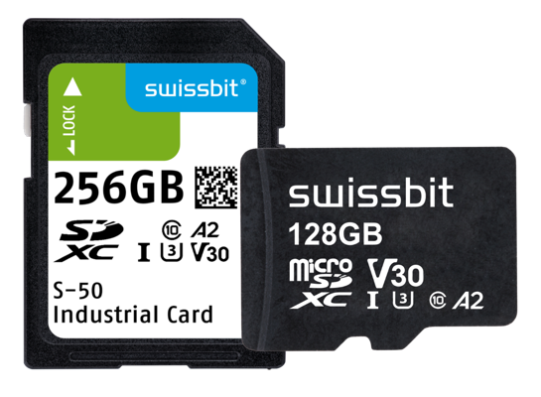  Image source: Swissbit  Swissbit S-5x: Memory card family for demanding applications | 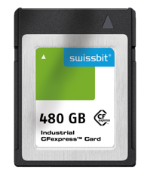  Image source: Swissbit  New form factor: CFexpress-card series G-2x
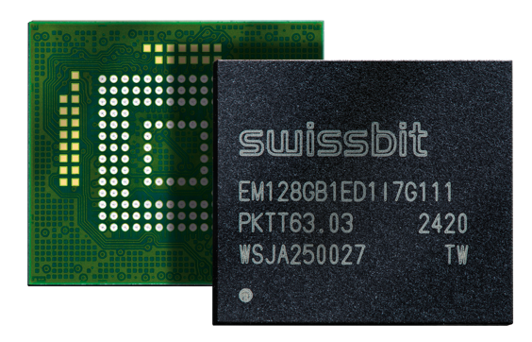 Image Source: Swissbit  Swissbit EM-30: robust and cost-efficient memory solution for embedded applications. | 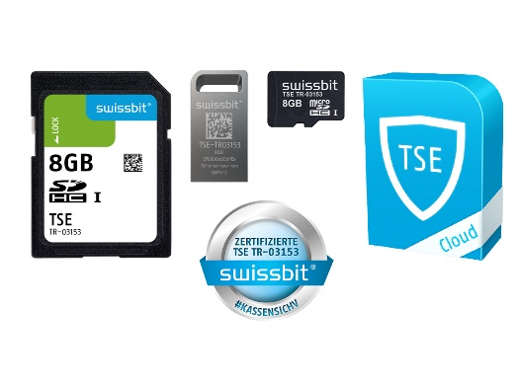 Image Source: Swissbit  Deadline March 31: the Swissbit TSE portfolio for the legally compliant conversion of cash registers and POS systems.
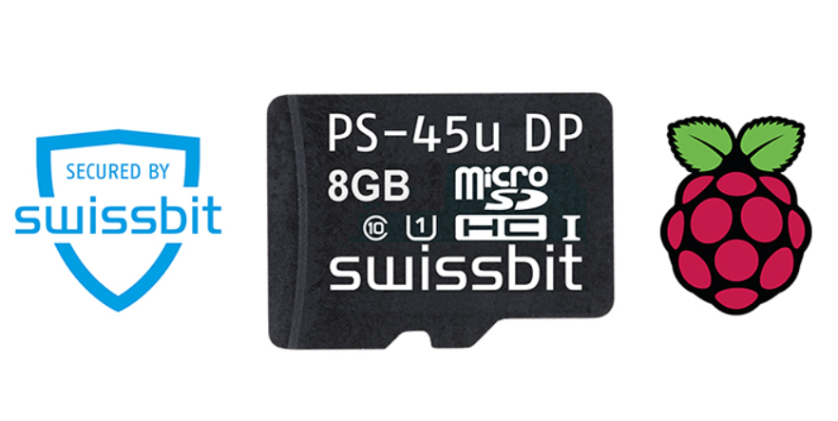  Image Source: Swissbit  Universal security solution for Raspberry Pi: the Swissbit Secure Boot Solution. |   Image Source: Swissbit  At embedded world 2021, Swissbit will premier its plug-&-play security solution "iShield Camera".
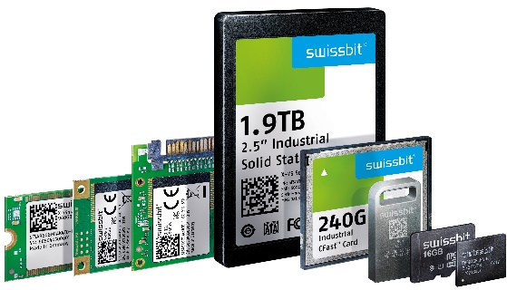  Image Source: Swissbit  Swissbit at embedded world 2021: industry-optimized storage products and hardware-based security solutions for the IoT. |   Image Source: Swissbit  The new Swissbit factory in Berlin offers everything for complex precision manufacturing of state-of-the-art, industry-optimized memory and security modules.

About Swissbit
Swissbit AG is the only independent European manufacturer of storage and embedded IoT solutions for demanding applications. Swissbit combines its unique competences in storage and embedded IoT technology with its advanced packaging knowhow. This expertise allows our customers to reliably store and protect data in critical industrial, NetCom, automotive, medical and finance applications as well as across the Internet of Things (IoT).
Swissbit develops and manufactures industrial-grade storage and security products “Made in Germany” with high reliability, long-term availability, and custom optimization.
Swissbit’s storage range includes SSDs with PCIe and SATA interface such as mSATA, Slim SATA, CFast™, M.2 and 2.5” as well as CompactFlash, USB flash drives, SD Memory Cards, micro SD Memory Cards and managed NAND BGAs like e.MMC. Security products are available in various application specific editions as USB flash drives, SD Memory Cards, and micro SD Memory Cards.
Swissbit was founded in 2001 and has offices in Switzerland, Germany, USA, Japan and Taiwan. Swissbit owns the registered trademarks Swissbit® and Hyperstone®. Since 2020, the independent investment firm Ardian is holding a majority stake in the company to support its growth.
For further information, please visit www.swissbit.com

Regional Headquarters:
Swissbit Germany AG
Bitterfelder Strasse 22
12681 Berlin
Germany
Tel: +49 30 936 954 0
Email: info@swissbit.com
www.swissbit.com
Headquarters:
Swissbit AG
Industriestrasse 4
9552 Bronschhofen
Switzerland
Tel: +41 71 913 03 03
Email: info@swissbit.com
www.swissbit.com

Contact:  Swissbit AG  Marian Weber  Industriestrasse 4  9552 Bronschhofen  Switzerland  Tel: +49 172 854 88 26  Email: marian.weber@swissbit.com  www.swissbit.com | Press Agency:  HighTech communications GmbH  Brigitte Basilio  Brunhamstrasse 21  81249 Munich  Germany  Tel: +49 89 500778-20  Fax: +49 89 500778-77  Email: b.basilio@htcm.de  www.htcm.de

