PRESS RELEASE

Würth Elektronik eiSos introduces a new manual
ABC of Power Modules
Waldenburg (Germany), 24 February 2016 – Würth Elektronik eiSos is releasing a new manual: "ABC of Power Modules – Functionality, Structure and Handling of a Power Module" is the first practical manual specifically about using components to control DC voltage.
The manual explains the basics of voltage control and frequently used switching topologies. The mechanical design of a power module is described as well as its impact on EMC and heat management. "ABC of Power Modules“ offers numerous practical tips on questions about layout, control, switching and it describes storage and handling as well as the manufacturing and soldering processes. Another chapter is dedicated to measuring procedures needed to obtain meaningful results for assessing power modules. The book concludes with instructions for selecting a module based on important parameters and criteria.
Authors with experience
A three-person team of authors is behind this latest work in the series of practical manuals from Würth Elektronik: Steffen Wolf has been at Würth Elektronik eiSos since 2014 in Business Development Management for the MagI³C power modules; Ralf Regenhold is Manager of the MagI³C Power Module Division at Würth Elektronik eiSos; and Jan Stephan is Business Development Manager for the product series of power modules.
"ABC of Power Modules“ is now available from Würth Elektronik and in bookstores. Price € 9.90, ISBN 978-3-89929-315-9.

Available images
The following images can be downloaded from the Internet in printable quality: http://www.htcm.de/kk/wuerth
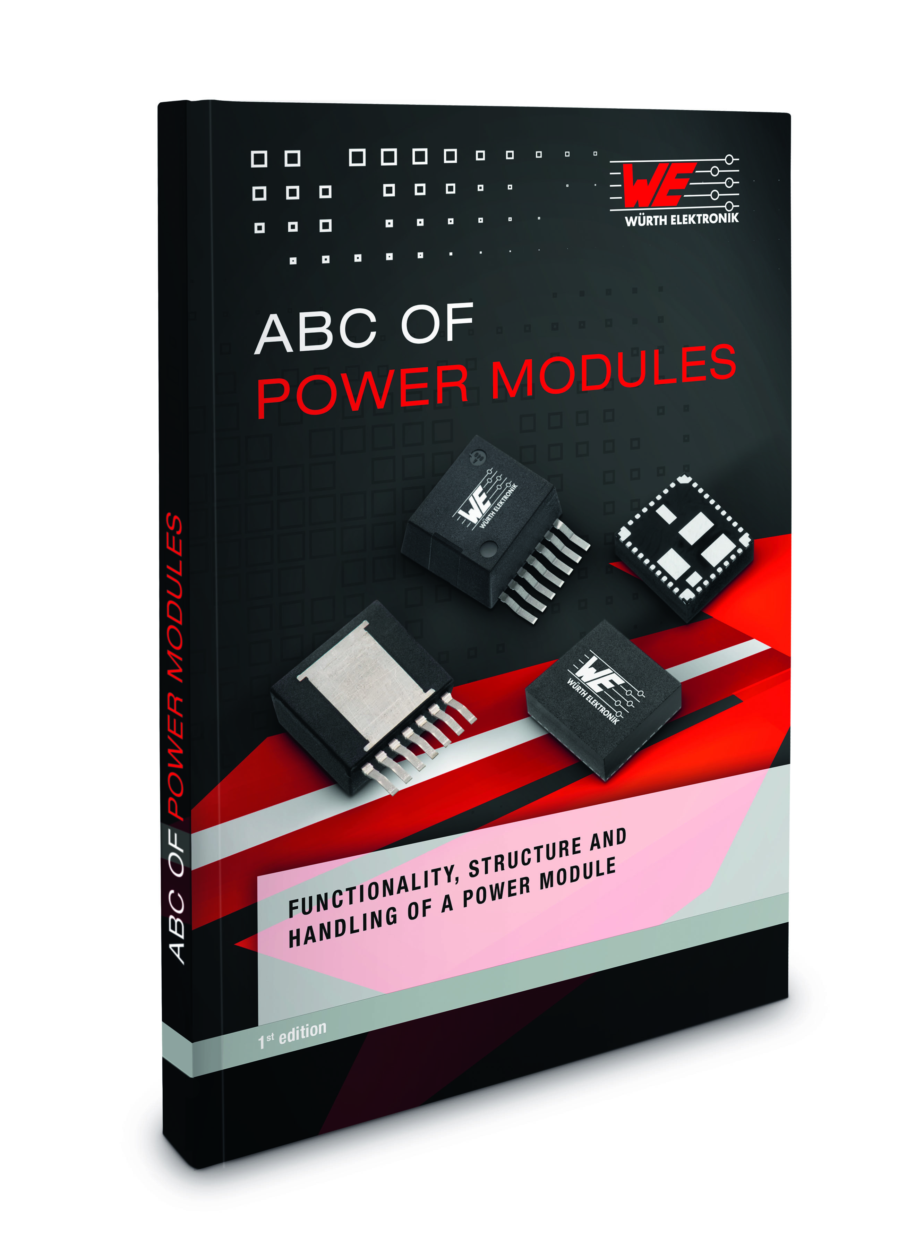
Image source: Würth Elektronik eiSos
New manual from Würth Elektronik eiSos: "ABC of Power Modules – Functionality, Structure and Handling of a Power Module."

About Würth Elektronik eiSos GmbH & Co. KG

Würth Elektronik eiSos GmbH & Co. KG is a manufacturer of electronic and electromechanical components for the electronics industry. The company is part of the Würth Group, the global market leader for fastener technology. It employs 6,100 people and generated sales of almost 475 million Euros in 2015. Würth Elektronik eiSos is active in 50 countries worldwide.
Manufacturing facilities in Europe, Asia and North America ensure delivery to a customer base that is growing worldwide. The product range covers EMC components, inductors, transformers, HF components, varistors, capacitors, power modules, LEDs, connectors, power elements, switches, assembly technology and fuse holders.
Würth Elektronik eiSos is one of Europe's largest manufacturers of passive components.
Würth Elektronik: more than you expect!
Further information at www.we-online.com

Further information:  Würth Elektronik eiSos GmbH & Co. KG  Sarah Hurst  Max-Eyth-Strasse 1  74638 Waldenburg  Germany  Phone: +49 7942 945-5186  E-mail: sarah.hurst@we-online.de  www.we-online.de | Press contact:  HighTech communications GmbH  Brigitte Basilio  Grasserstrasse 1c  80339 Munich  Germany  Phone: +49 89 500778-20  Fax: +49 89 500778-77  E-mail: b.basilio@htcm.de  www.htcm.de

